**PRACTICAL NO:01**

**AIM: OLAP with Oracle: Analytical Queries Roll_UP, CUBE, First, Last, Lead, Lag, Rank AND Dense Rank, Windowing functions ROWS-NPRECEDING AND FOLLOWING**

>>> CREATE TABLE student1 ( rollno NUMBER,

name VARCHAR2(10),

subject VARCHAR2(7), marks NUMBER

);

>>> INSERT INTO student1 VALUES (10, 'Rohan', 'ADTA', 67); INSERT INTO student1 VALUES (11, 'Mohan', 'ADS', 57); INSERT INTO student1 VALUES (12, 'Rishi', 'MFCS', 47); INSERT INTO student1 VALUES (13, 'Kavya', 'SPM', 38); INSERT INTO student1 VALUES (14, 'Neha', 'MFCS', 37); INSERT INTO student1 VALUES (15, 'Mitali', 'AWT', 35);

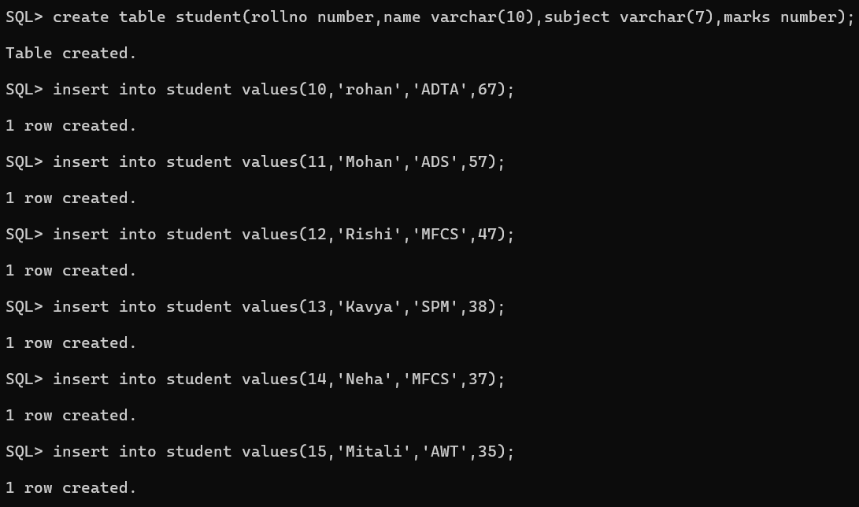

>select*from student

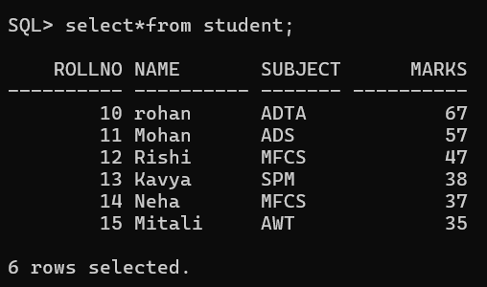

1. **Rank and Dense rank**

SQL> select rollno,name,marks,subject,rank() over(partition by subject order by marks) as "rank" from student;

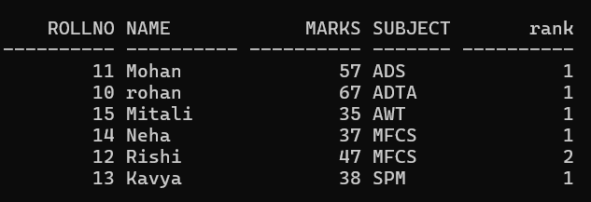

SQL> select rollno,name,subject,marks,subject,rank() over(partition by subject order by marks desc) as "rank" from student;

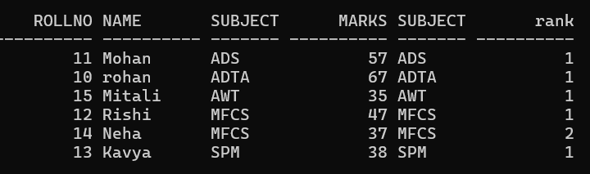

1. **First and last**

SQL> select rollno,name,subject,marks,max(marks) keep(dense_rank first order by marks) over(partition by subject) as "highest" from student order by subject marks;

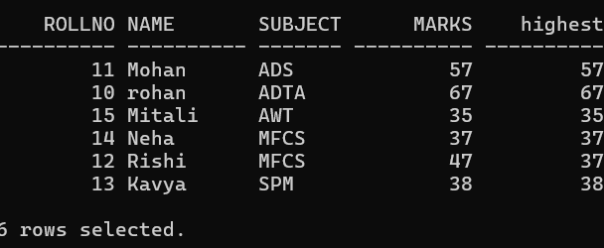

SQL> select rollno,name,subject,marks,min(marks) keep(dense_rank first order by marks) over(partition by subject) as "lowest" from student1 order by sub

ject,marks;

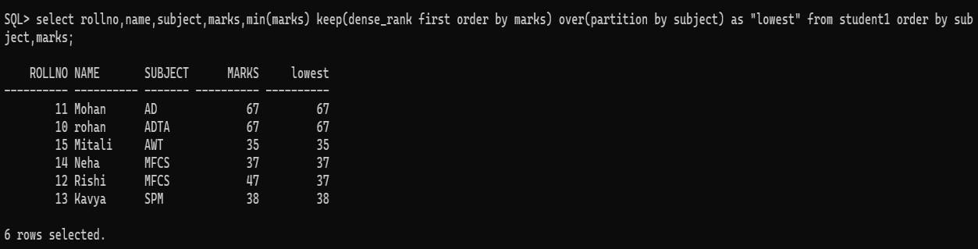

SQL> SELECT rollno, name, marks, subject, MIN(marks) KEEP (DENSE_RANK FIRST ORDER BY marks) OVER (PARTITION BY subject) AS "lowest", MIN(marks) KEEP (DENSE_RANK LAST ORDER BY marks) OVER (PARTITION BY subject) AS

"highest"FROM student1ORDER BY subject, marks;

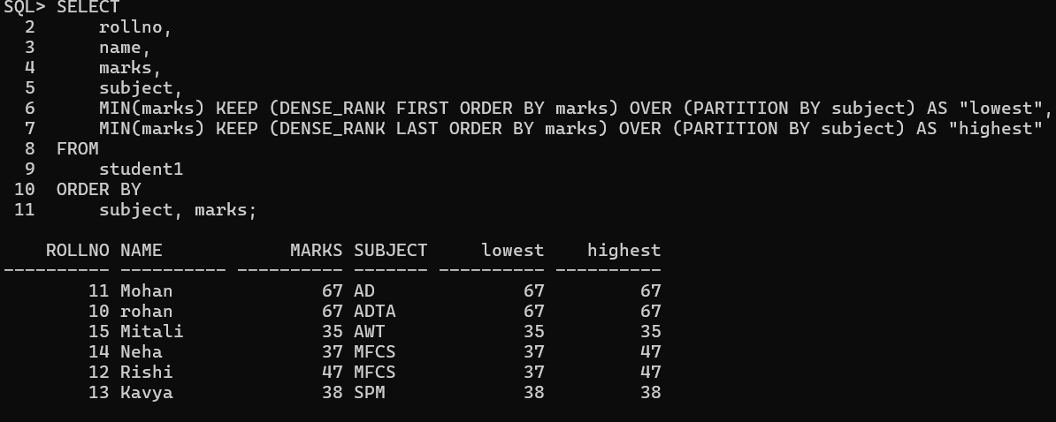

>>>CREATE TABLE emp (

empid INT,

empname VARCHAR(10), dept VARCHAR(20),

salary INT

);

>>>INSERT INTO emp VALUES (1, 'Ram', 'marketing', 10000);

INSERT INTO emp VALUES (2, 'Nita', 'marketing', 103000); INSERT INTO emp VALUES (3, 'Raj', 'marketing', 10500); INSERT INTO emp VALUES (4, 'Shilpa', 'IT', 10500; INSERT INTO emp VALUES (5, 'Prapti', 'IT', 11100); INSERT INTO emp VALUES (6, 'Mitali', 'sales', 12100); INSERT INTO emp VALUES (7, 'Moksh', 'sales', 13100);

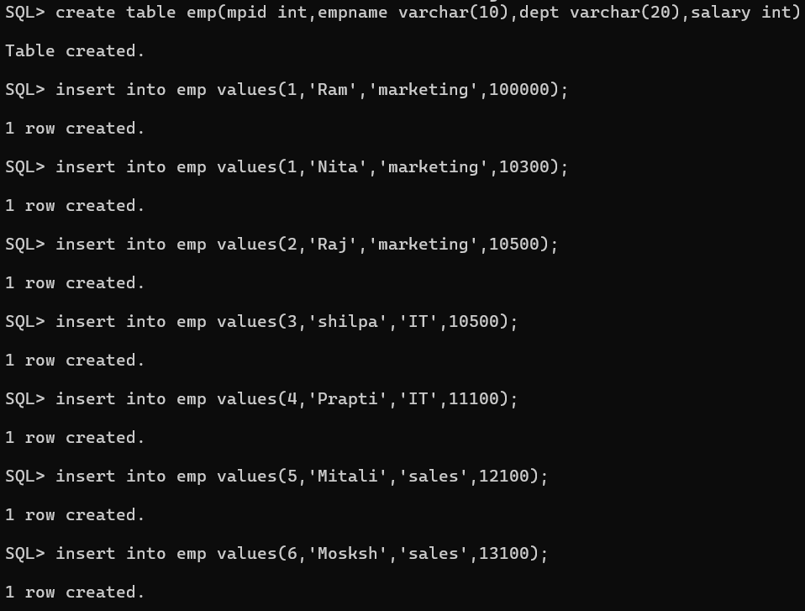

>>select*from emp;

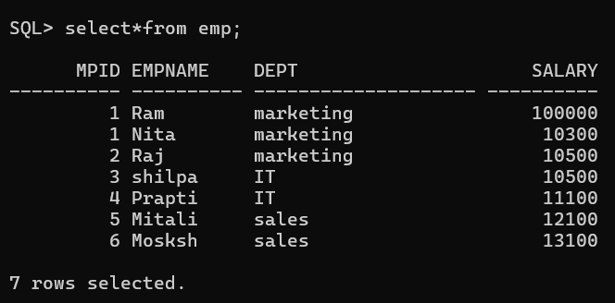

1. **Lag and lead**

SQL> select mpid,empname,dept,salary,lag(salary,1,0)

2 over(partition by dept order by salary) as "previous" from emp;

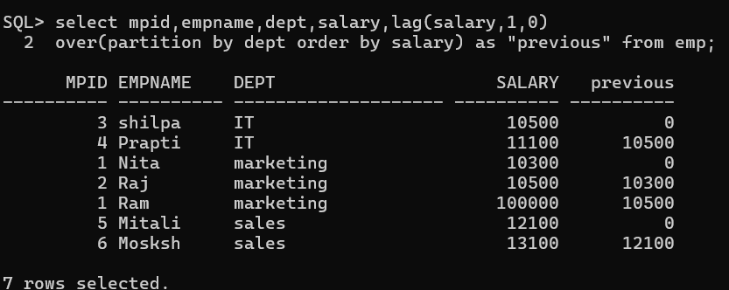

SQL> select mpid,empname,dept,salary,lead(salary,1,0)

2 over(partition by dept order by salary) as "previous" from emp;

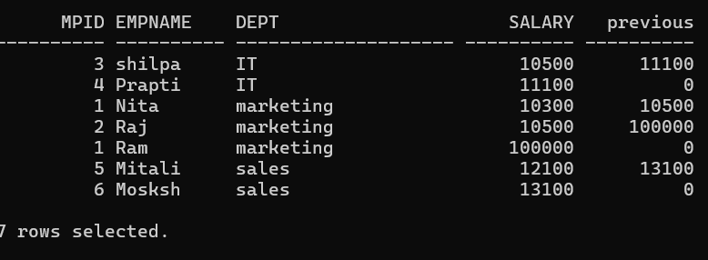

1. **Roll Up and Cube**

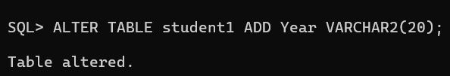SQL>ALTER TABLE student1 ADD Year VARCHAR(20);

SQL>insert into student1 values(16,’Ayush,’MAFS’,56,’FY’); SQL>insert into student1 values(17,’Rutuja’,’SPM’,68,’FY’); SQL>insert into student values(18,’Sakshi’,’AWT’,68,’FY’); SQL>insert into student1 values(19,’Mahesh’,’ADTA’,67,’SY’);

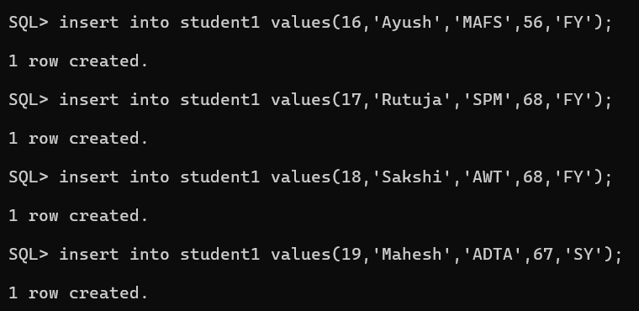

SQL>select*from student1;

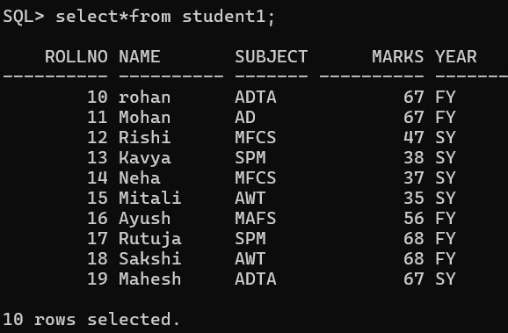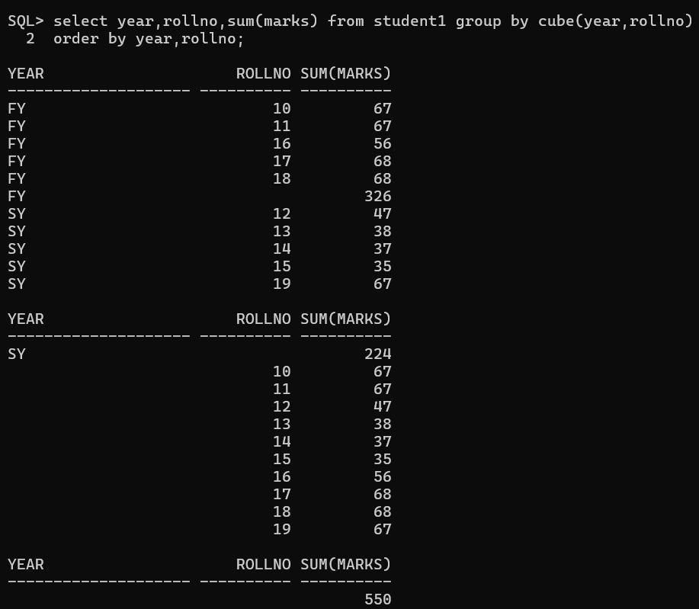SQL> select year,rollno,sum(marks) from student1 group by cube(year,rollno) 2 order by year,rollno;

Range Partition

**2. Roll up**

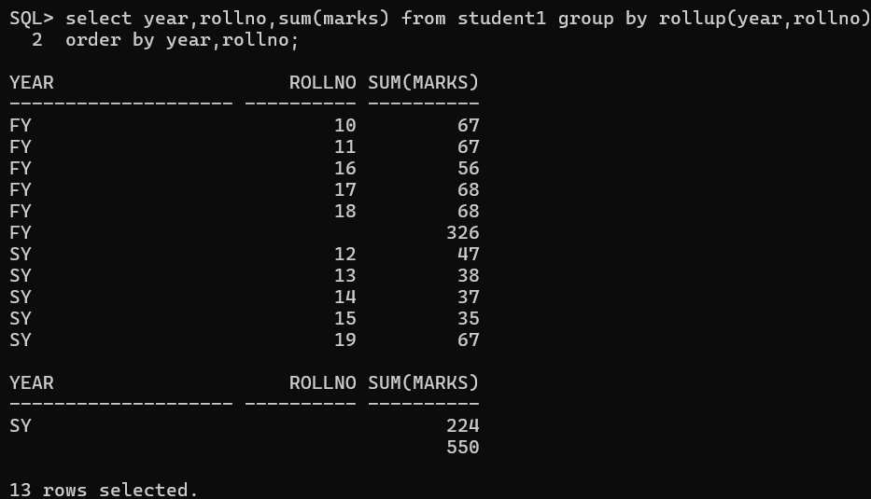SQL> select year,rollno,sum(marks) from student1 group by rollup(year,rollno) 2 order by year,rollno;

>>SELECT mpid, salary, dept,

2 FIRST_VALUE(salary) OVER (ORDER BY salary ROWS BETWEEN 1 PRECEDING AND CURRENT ROW) AS "previous",

3 LAST_VALUE(salary) OVER (ORDER BY salary ROWS BETWEEN CURRENT ROW AND 1 FOLLOWING) AS "next"

4 FROM emp;

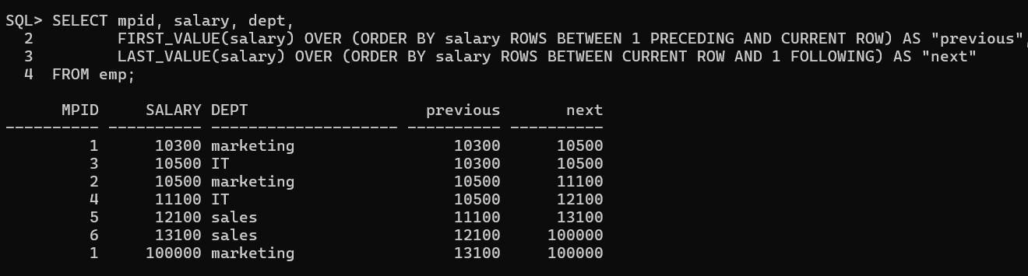

**PRACTICAL No.2**

**AIM: Implementation of Partitions: Range, List**

>>>CREATE TABLE sales_range2( Salesman_id NUMBER(5), Salesman_name VARCHAR(30), Sales_amount NUMBER(10), Sales_date DATE)

PARTITION BY RANGE (sales_date)(

PARTITION sales_janVALUES LESS THAN(TO_DATE(‘31/01/2000’,’DD/MM/YYYY’)), PARTITION sales_feb VALUES LESS THAN(TO_DATE(‘28/02/2000’,’DD/MM/YYYY’)), PARTITION sales_mar VALUES LESS THAN(TO_DATE(‘31/03/2000’,’DD/MM/YYYY’))

PARTITION sales_apr VALUES LESS THAN (TO_DATE(‘30/04/2000’,’DD/MM/YYYY))),

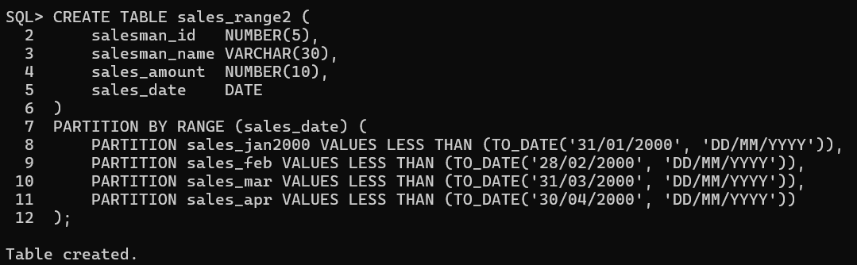

SQL>insert into sales_range2 values(1,’Ram’,7000,to_date(‘15/01/2000’,’DD/MM/YYYY’));

SQL>insert into sales_range2 values(2,’kiran’,12000,to_date(‘12/04/2000’,’DD/MM/YYYY’));

SQL>>insert into sales_range2 values(3,’ankit’,15000,to_date(‘12/03/2000’,’DD/MM/YYYY));

SQL>>insert into sales_range2 values(4,’nehali’,16000,todate(‘18/02/2000’,’DD/MM/YYYY’)),

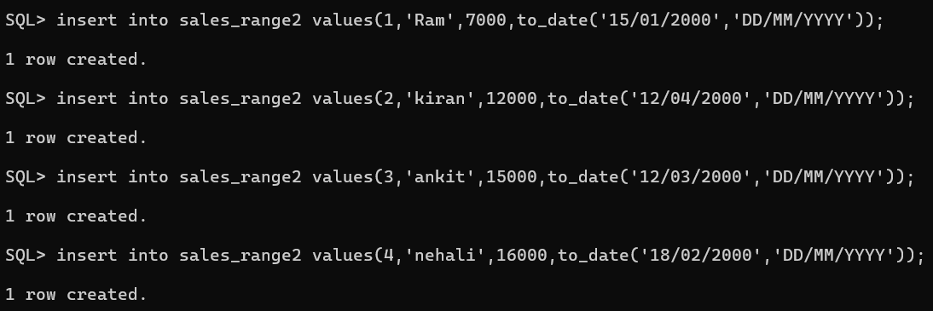

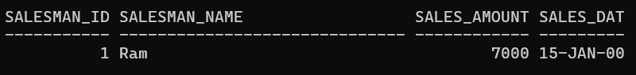SQL> select*from sales_range2 2 partition(sales_jan2000);

**List Partition**

SQL>CREATE TABLE sale_list1( Salesman_id NUMBER(5), Salesman_name VARCHAR(30), Sales_state VARCHAR2(20), Sales_amount NUMBER(10), Sales_date DATE)

PARTITION BY LIST (sales_state)(

PARTITION sales_west VALUES (‘California’,’Hawai’), PARTITION sales_east VALUES(‘New York’,’Virginia’,Florida’), PARTITION sales_central VALUES(‘Texas’,’Illinois’), PARTITION sales_other VALUES(DEFAULT));

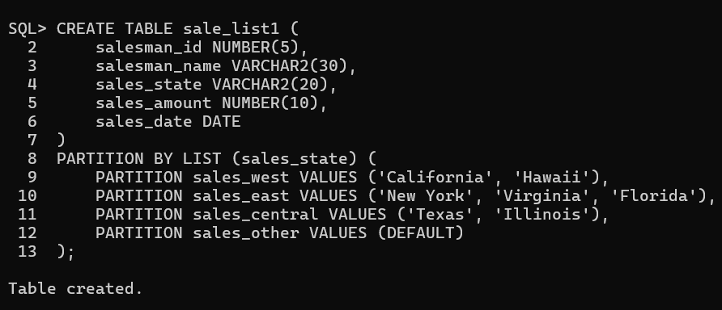

SQL>insert into sale_list1 values(101,’Rajiv’,’California’,2000,to_date(‘12/10/2023’,’DD/MM/YYYY’));

SQL>insert into sale_list1 values(102,’Rajani’,’Texas’,7000,to_date(‘12/10/2023’,’DD/MM/YYYY’));

SQL>insert into sale_list1 values(103,’Vimal’,’New York’,7000,to_date(‘14/11/2023’,’DD/MM/YYYY’));

SQL>insert into sale_list1 values(104,’Vimal’,’New York’,9000,to_date(‘10/09/2000’,’DD/MM/YYYY’));

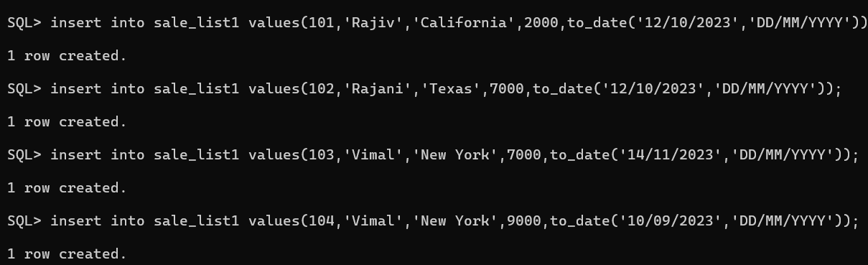

SQL>select*from sale_list1;

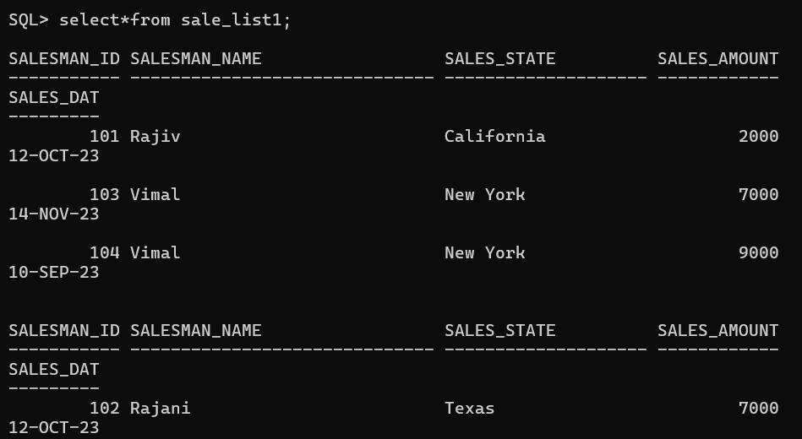

SQL> select*from sale_list1 PARTITION (sales_east);

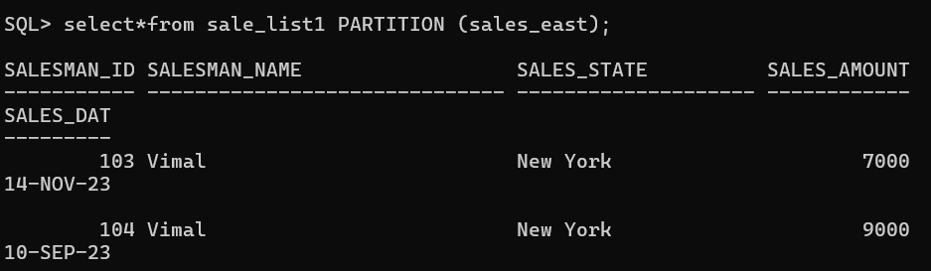

SQL> select*from sale_list1 PARTITION (sales_west);

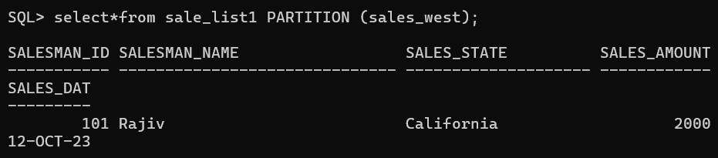

SQL> select*from sale_list1 PARTITION (sales_central);

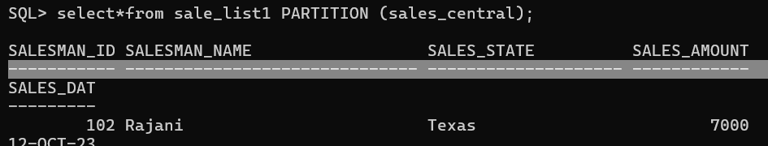

**Practical No.03**

**AIM: Implementation of, Abstract Data Type**

SQL> create type type_name As object(fname varchar2(20),mname varchar2(20),lname varchar2(20))/

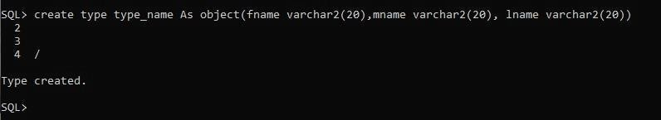

SQL>create type type_address As object(street varchar2(20),city varchar2(20),pincode varchar2(20))/

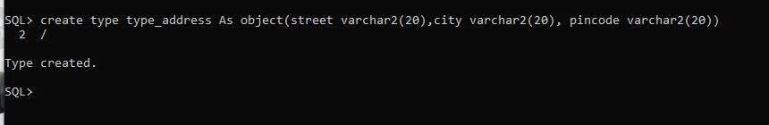

SQL>create table table2(c_id number(5) primary key,c_name type_name,c_add type_address,c_phone number(10));

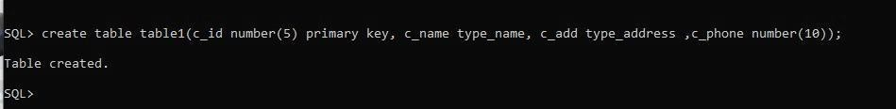

SQL> insert into table2 values(1,type_name('Raj','M','Nair'), 2 type_address('Kalina','Mumbai',123456),8789978876);

1 row created.

SQL> insert into table2 values(2,type_name('Ritesh','M1','Shaf'), 2 type_address('Colaba','Mumbai',123456),568786778);

1 row created.

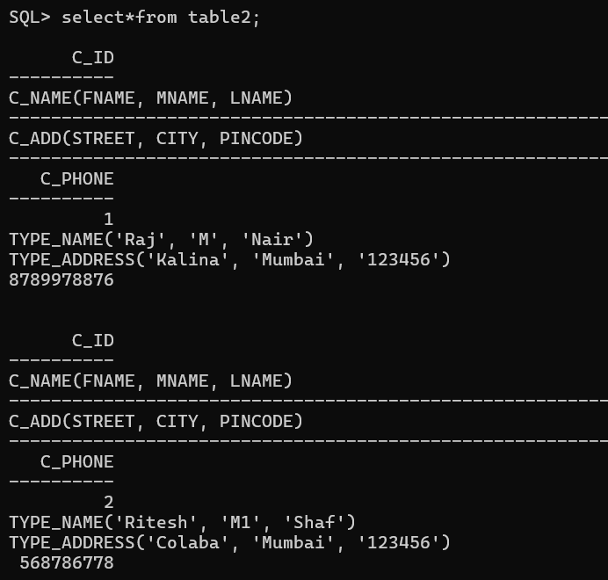

**Practical No.04**

**AIM : ETL through Pentaho: ETL Transformation with Pentaho. 1.Input**

1. **XL input**

**Step 1:In C Drive -> go to the “PENTAHO” folder**

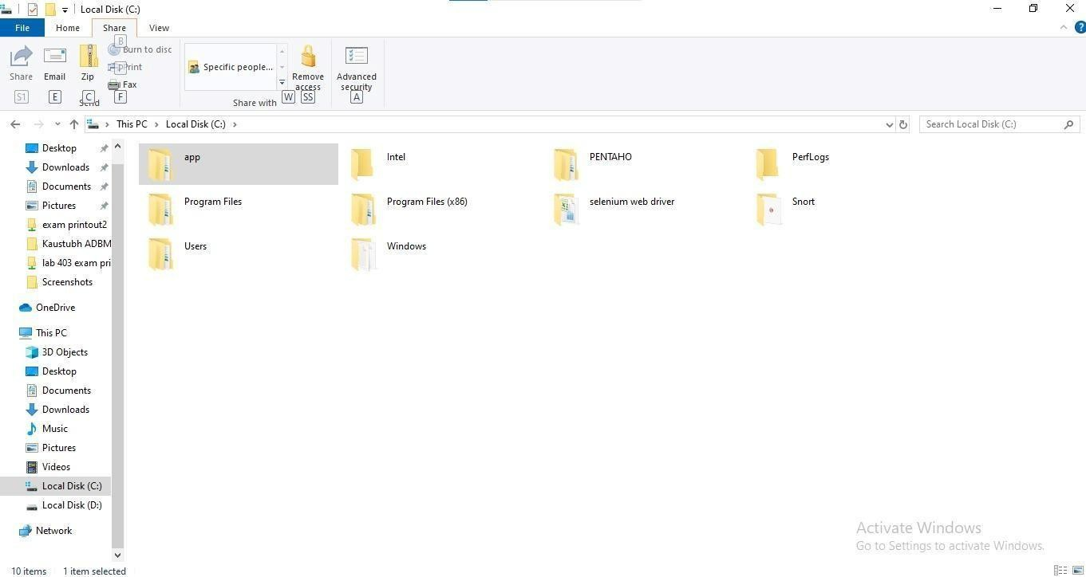

**Step 2: Click on the pdi folder**

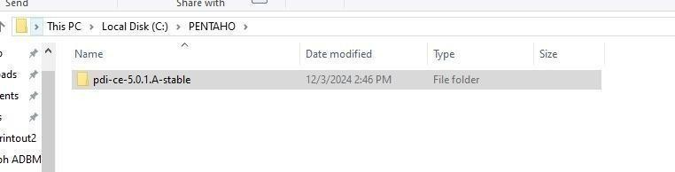

**Step 3: Inside the folder click on data-integration folder**

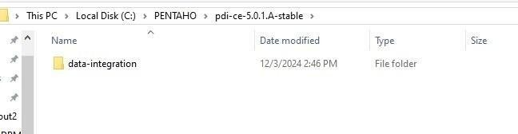

**Step 4:In data integration extract all jar files from the lib folder Step 5: Set system variable for java updated version java 1.8 Step 6: After Extracting all the jar files click on “spoon”**

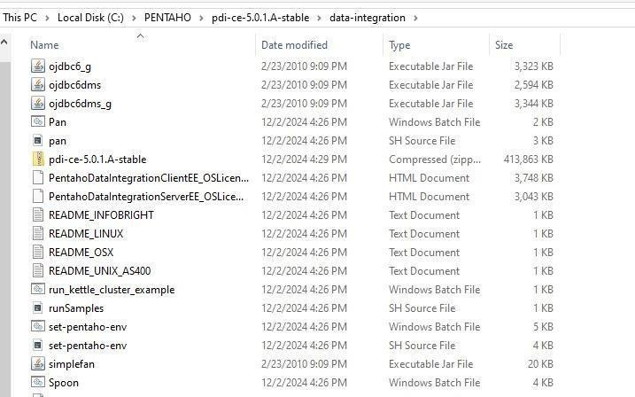

**Step 7: This window will appear click on the “cancel”**

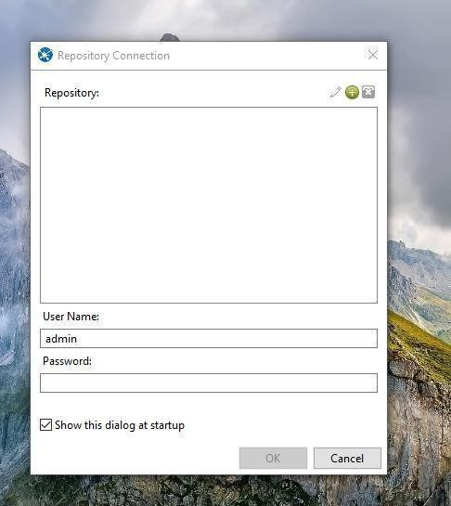

**Step 8: “PENTAHO” will be started**

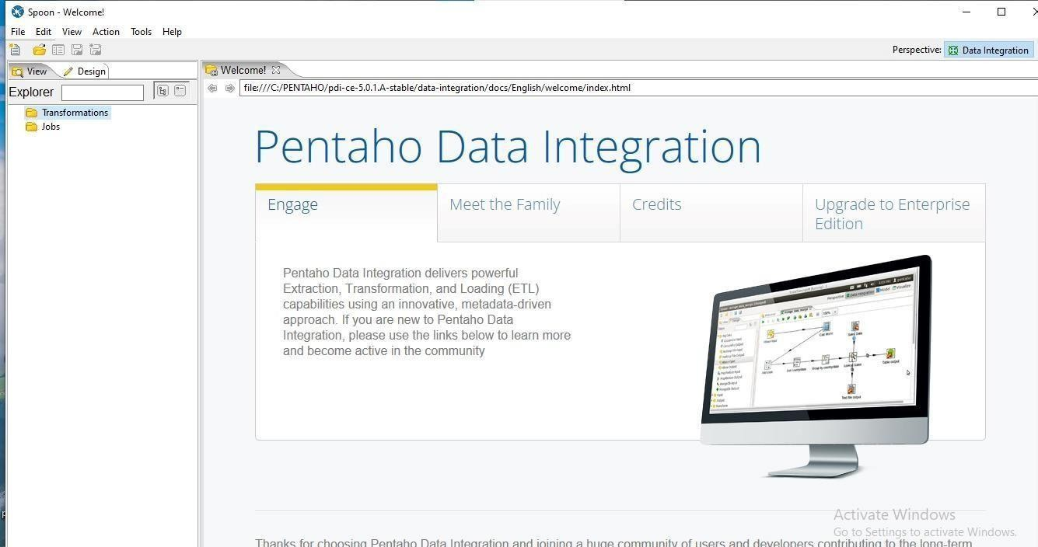

**Step 9: Run the Pentaho Data Integration tools (Spoon).**

**Step 10: Pull down the File menu and select the New menu item followed by Transformation.**

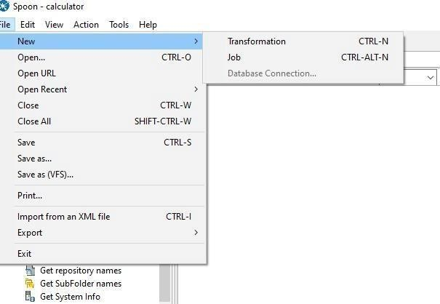

**Step 11: Drag “Microsoft Excel Input” form the “Input” folder and drag it on main window of Pentaho**

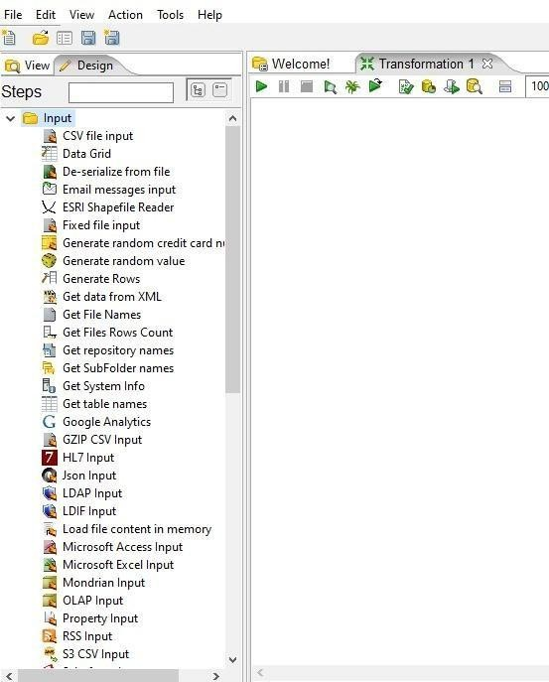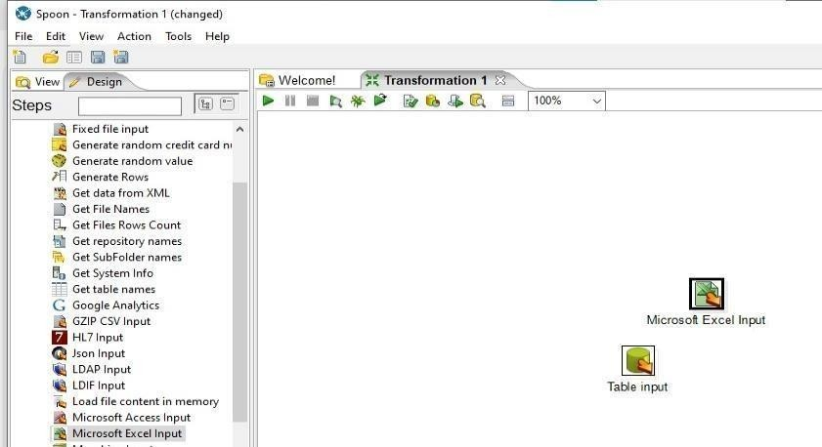

**Step 12: Double-click on the Microsoft Excel Input step to view its properties Click on the Browse button next to Filename field and navigate to the folder with the Excel files. Select the Excel file as shown below and then click the Open button.**

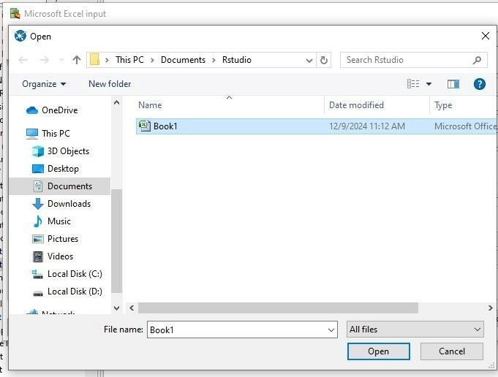

**Step 13: 5. Click on ADD button to add excel file .**

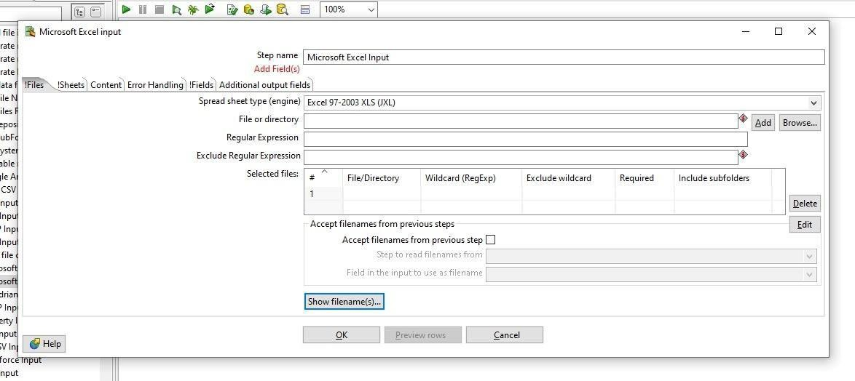

**Step 14: Navigate to Sheet tab to select the sheet which you want to select. And select Sheetname(s) Button. Following form will appear then select sheet and select (>) button to add sheet.**

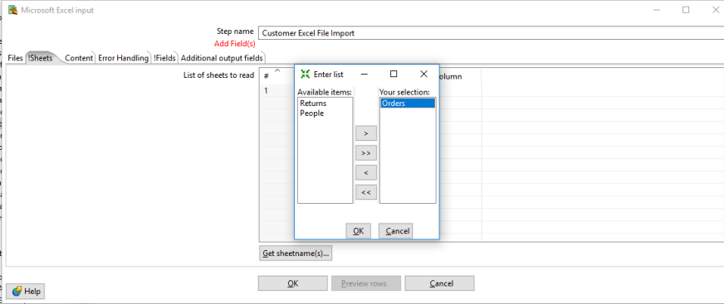

**Step 15: Navigate to Fields tab to assert the header name. Click on “Get Fields from header row” button to get column list .**

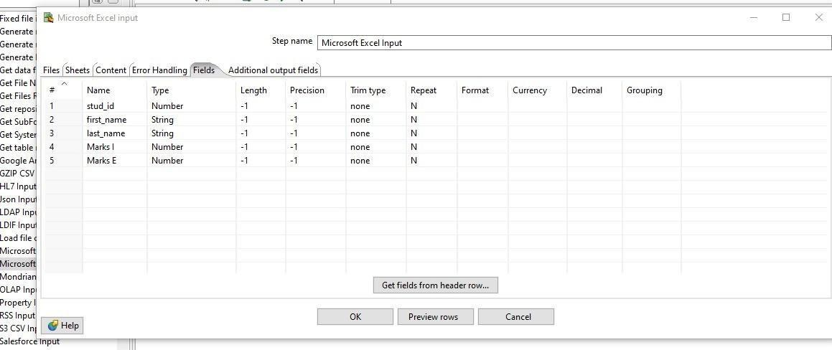

**Step 16: Click on “Preview Row” button to select top 1000 row.**

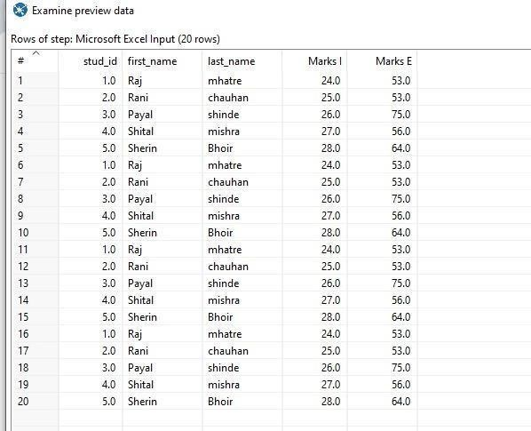

**(ii). Table input**

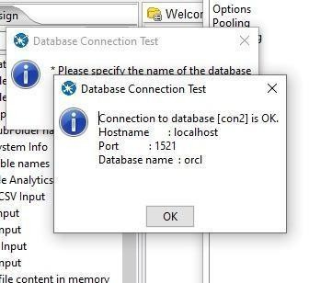

**Step 1: Double-click on the Table Input step to view its properties. Select “New” button to configure database connection. Or “Edit” button to edit previously configured connection.**

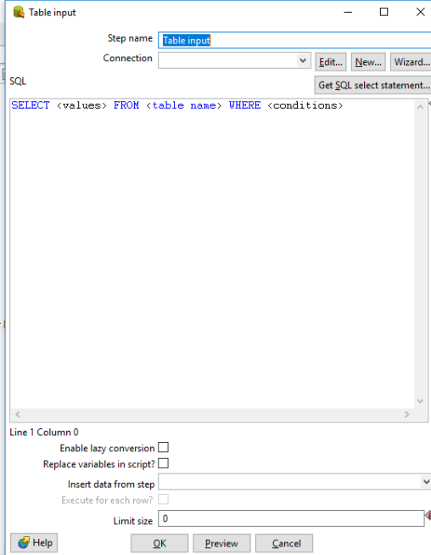

**Step 2: Fill the following connection information. And click on “Test” button to verify information.**

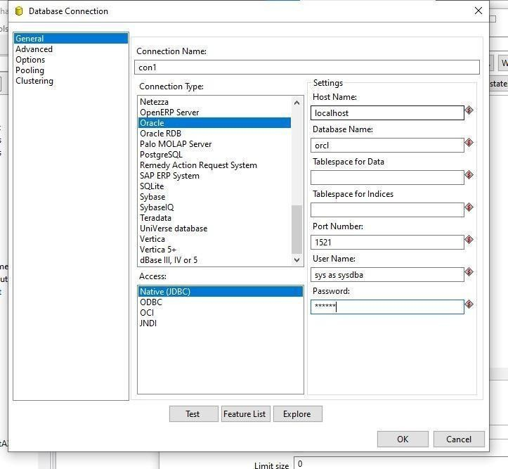

**Step 3: Click on “Get SQL select statement” to retrieve table data.**

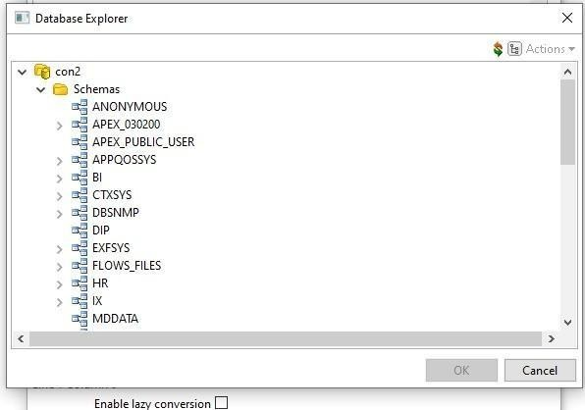

**Step 4: Select Table and click on OK. And Click on “Preview” button to preview data of selected table.**

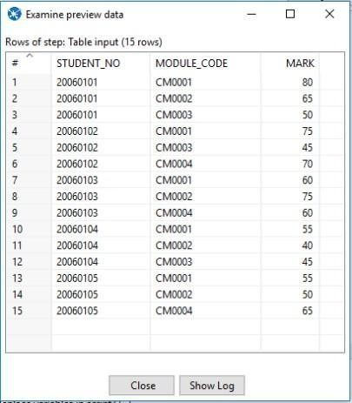

**Step 5: Click OK button to close the property window.**

1. **Output**

**Step 1: . Open up the Output folder and drag and drop the Table output / Microsoft excel output step on to the transformation window.**

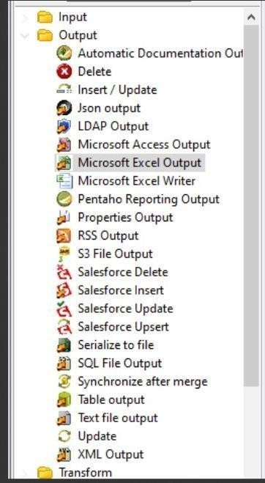

**Step 2: Double-click on the Microsoft Excel output step to view its properties Click on the Browse button next to Filename field and navigate to the folder to store the output**

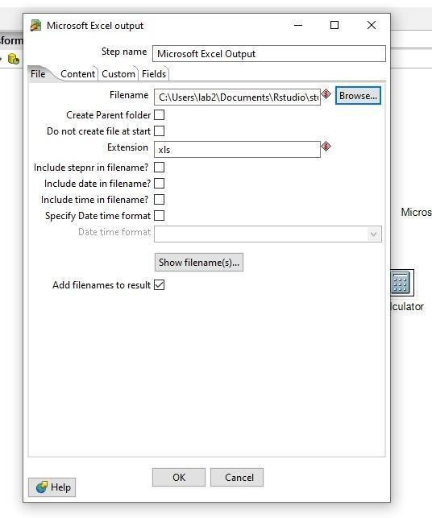

**Step 3: Make connection to input and output i.e. Create a hop between the Table Input and Microsoft Excel Output steps Go to field tab of Excel output step and click on “Get fields” button to retrieve column list of table data**

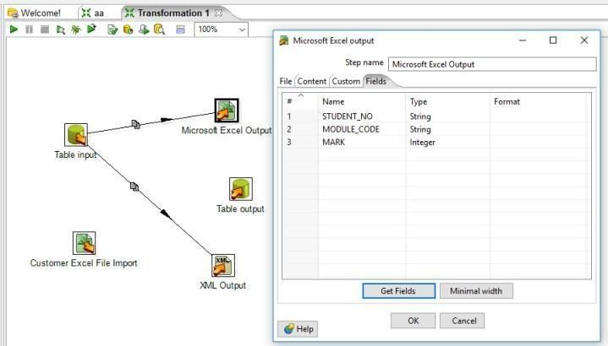

**Step 4: For Table output, make connection to input to table output. Double click on Table output. Select connection and target table which can be selected from browse button. Check Specify database fields to get Fields and click on “Get fields” button**

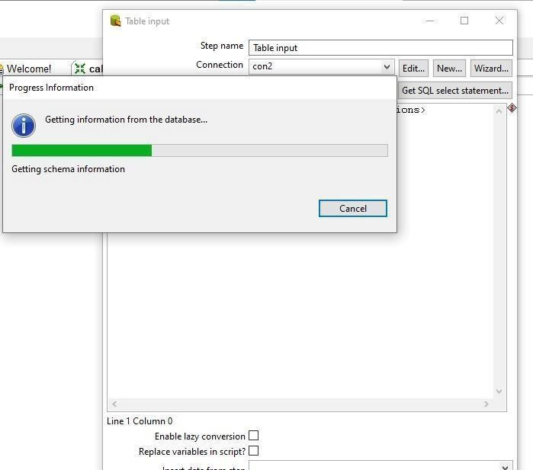

**5. Click OK to close the property window.**

1. **Transformations**
   1. **Calculator**

**Step 1:Make one excel sheet with some fields.**

**Step 2:Go to the PENTAHO ->Transformation->new transformation->Drag Microsoft Excel Input ->Drop it on the screen**

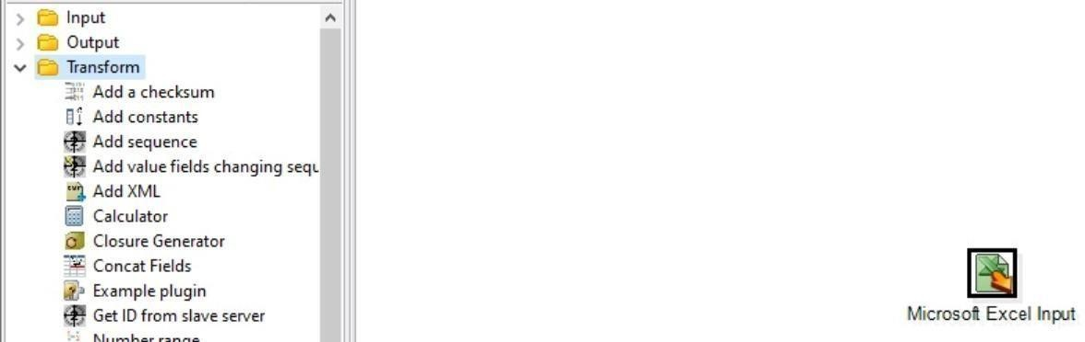

**Step 3: Double click on Microsoft Excel Input->add your file name in the given fields**



**Step 4: After adding click on sheets -> select sheets of the added file->Click on “Fields” and click on “Get fields from the header row” the fields of the selected should will be displayed**

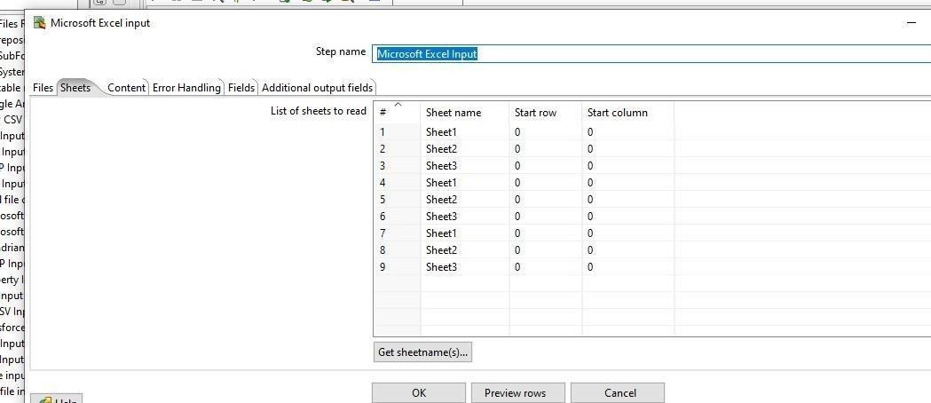

**Step 5: Click on “Previous rows for entries in the fields”**

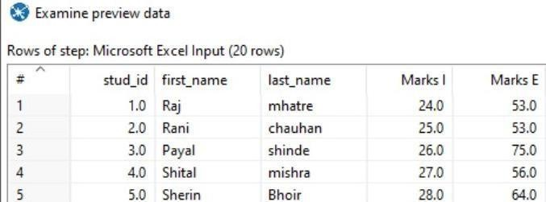

**Step 6: Add Calculator from the transformation and “Microsoft Excel**

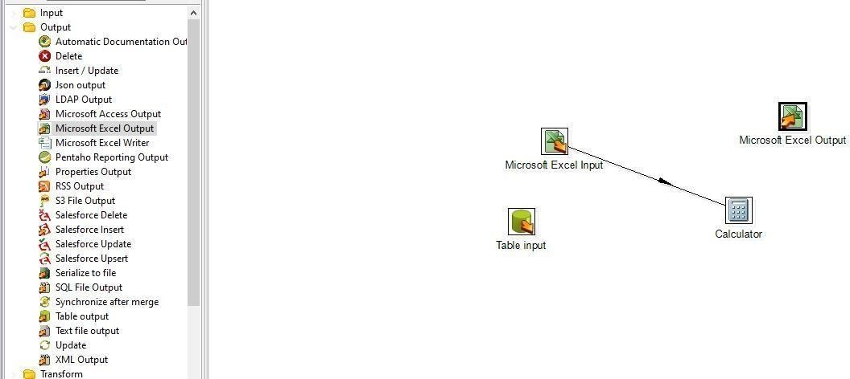

**Step 7: Double click on “Calculator” add the operation on which fields you want to perform which operation.**

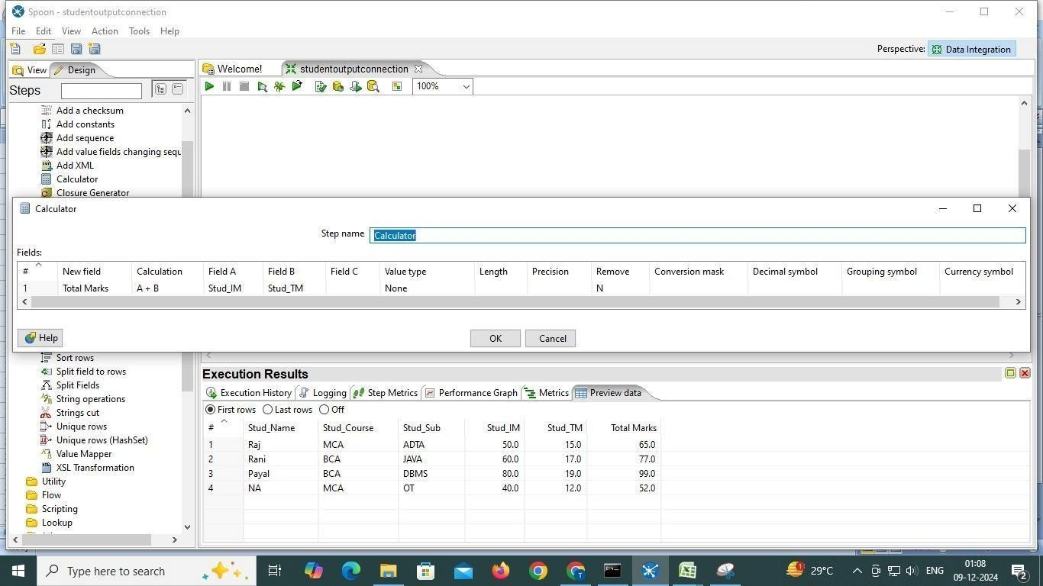

**Step 8: For displaying that operation connect “Microsoft Excel Input” with “Calculator” and “Calculator” with “Microsoft Excel Output”**

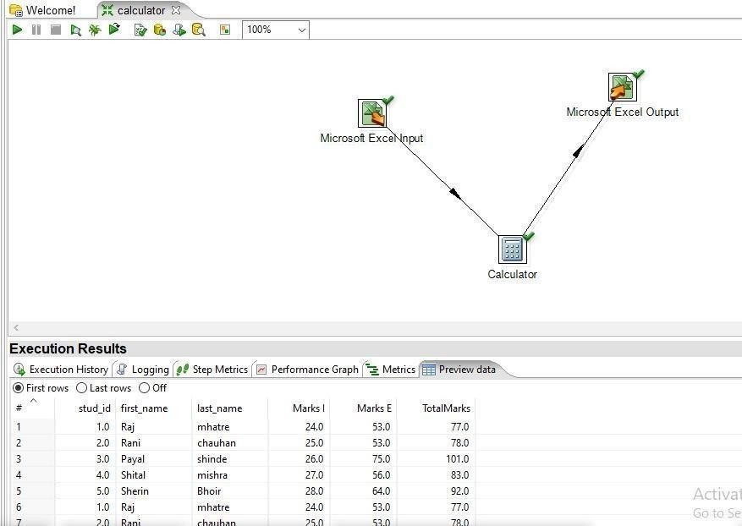

**Step 9: The “TotalMarks” field will be display on your excel sheet with extra field**

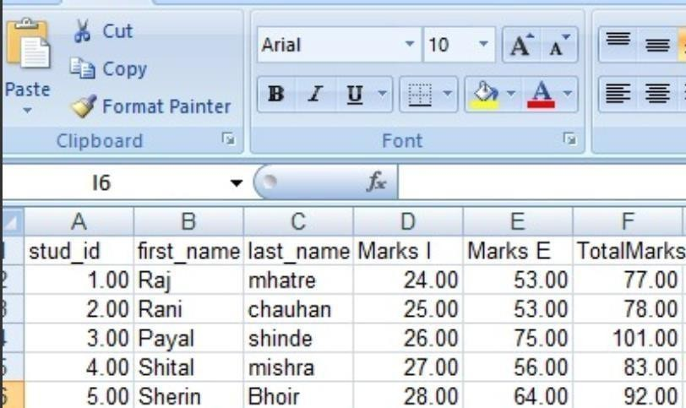

* 1. **Add Sequence**

**Step 1: In the “Pentaho” click on new-> Transformation**



**Step 2: Click on “Input” -> select “Microsoft Input Excel” and perform Input operation on it**

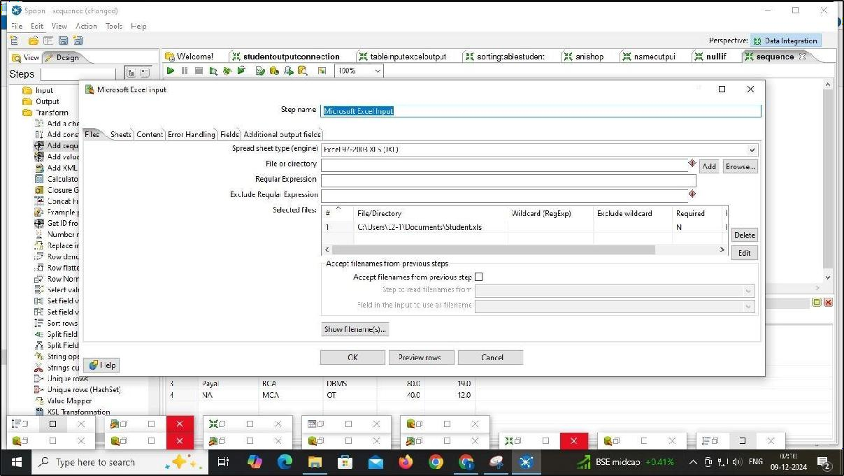

**Step 3:From the transformation drag “Add sequence” Connect “Microsoft Excel Input with it”Add**

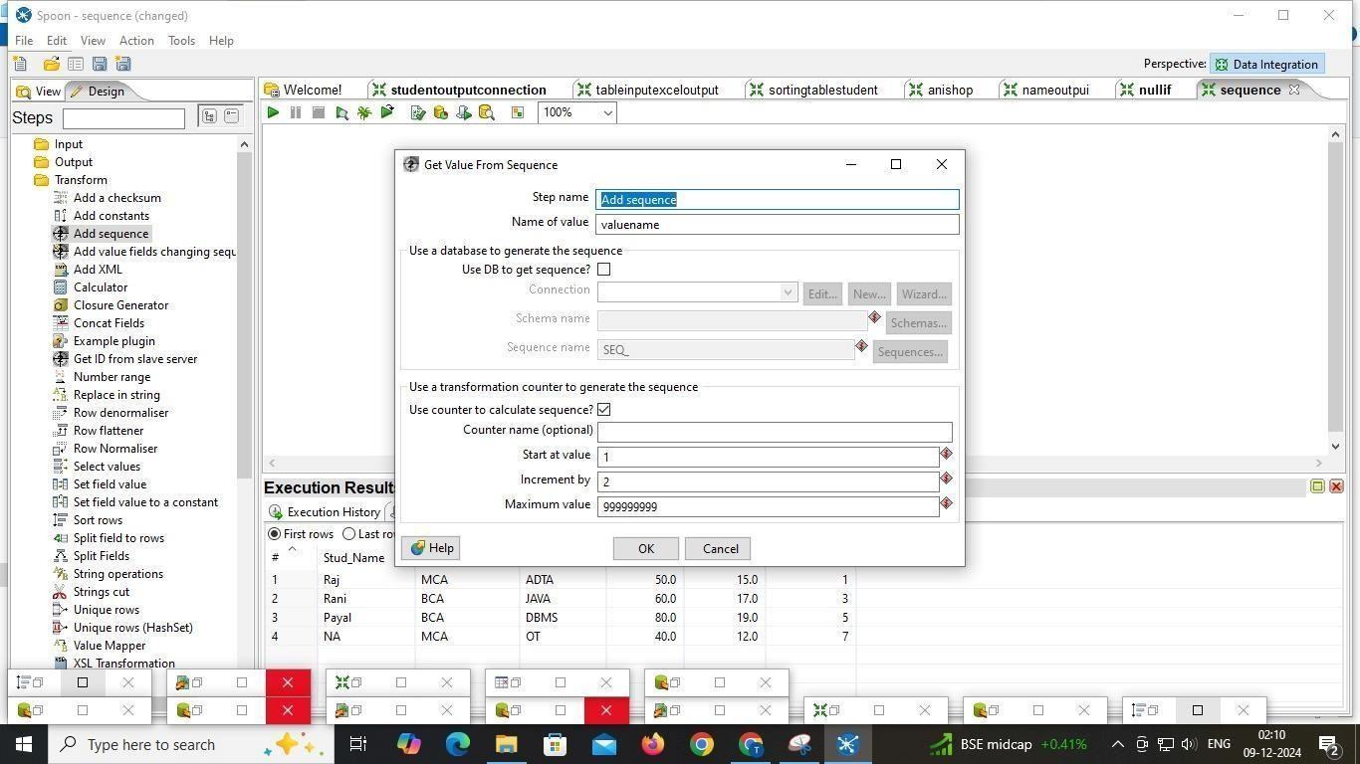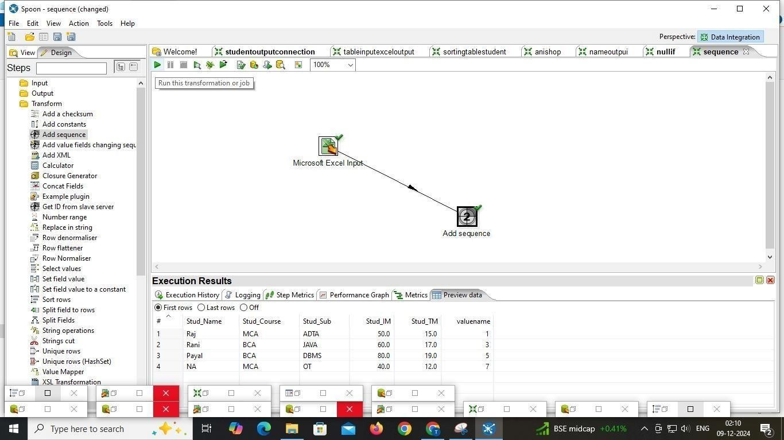

iii). Sorting

**Step 1: Pull down the File menu and select the New menu item followed by Transformation.**

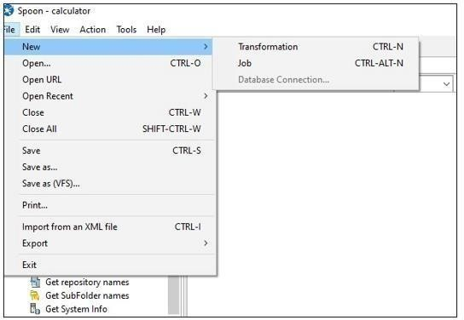

**Step 2: Add Student.xls file in input**

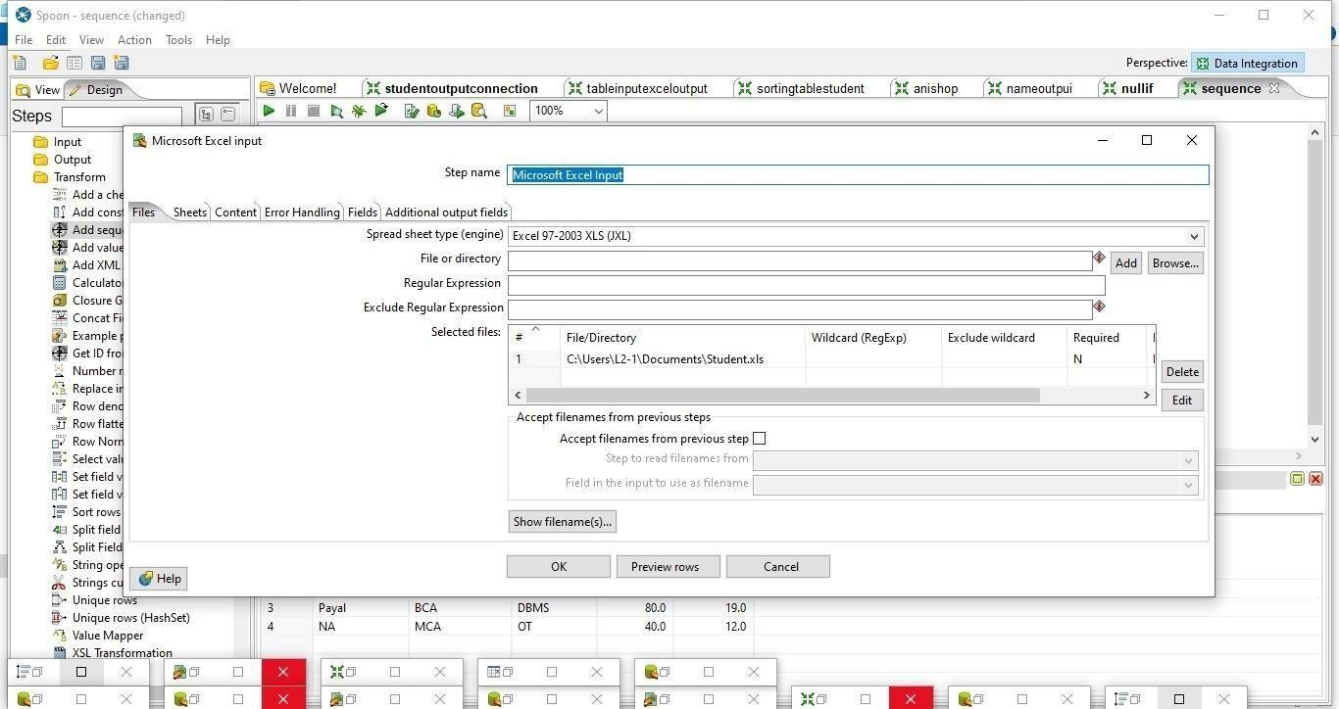

Step -2 Add Sheet In Microsft Excel input

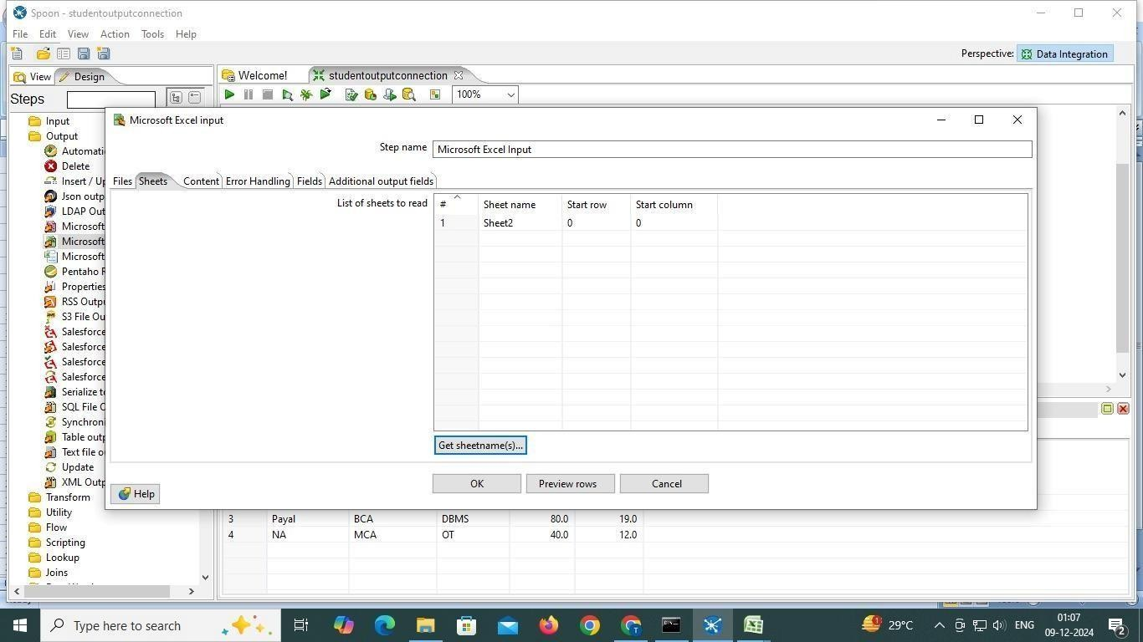

Step 4: Go to field section and Click on Get fileds

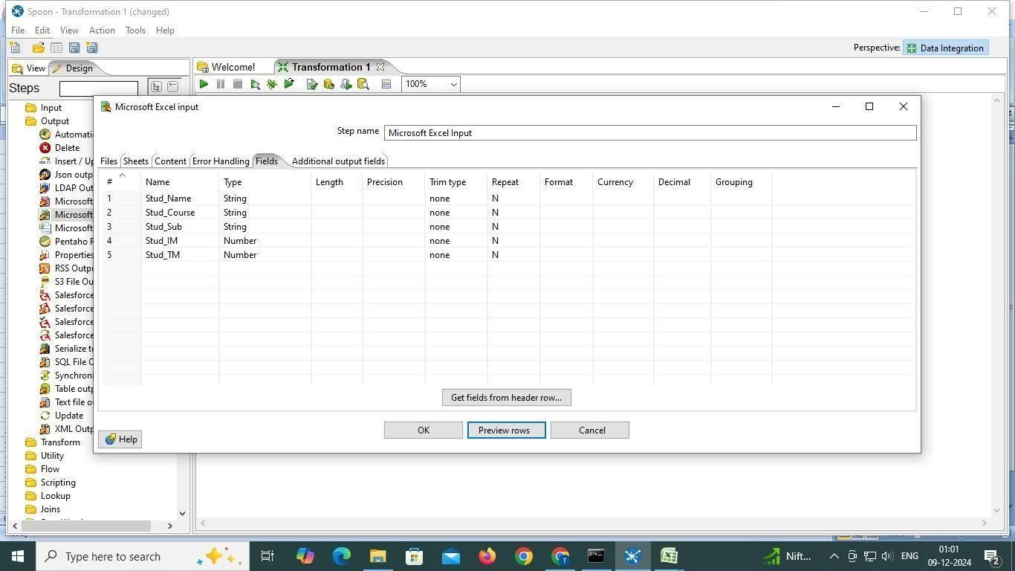

Step: 5 put 100 and click ok

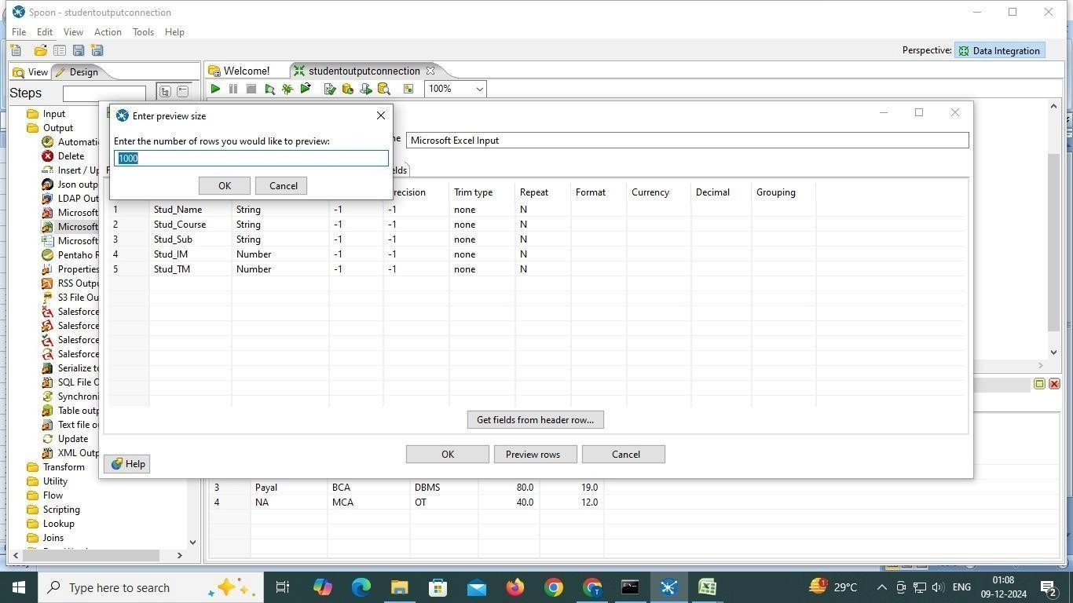

Step :6 add Sort

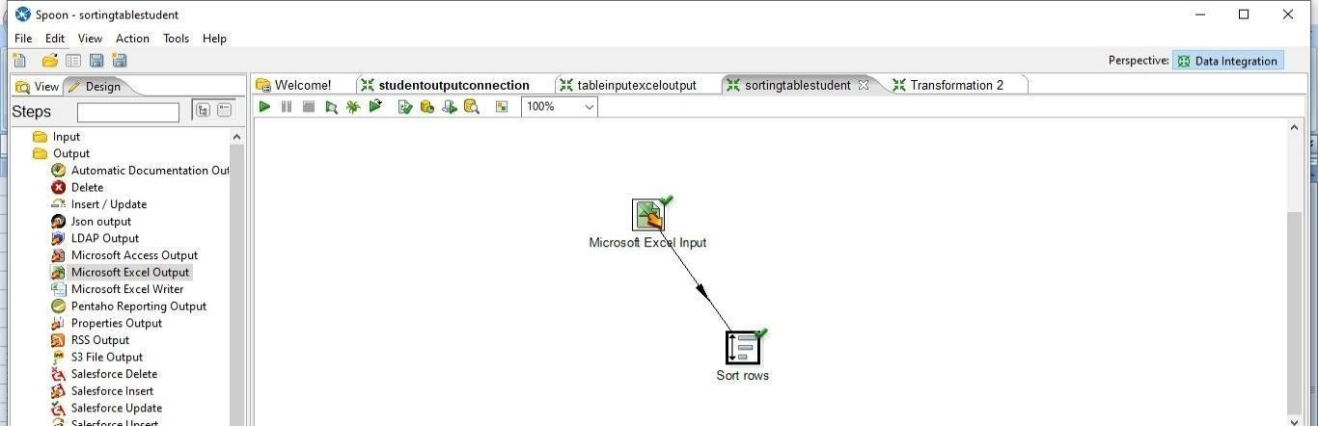

Step 7:- add these in sort by double click on it

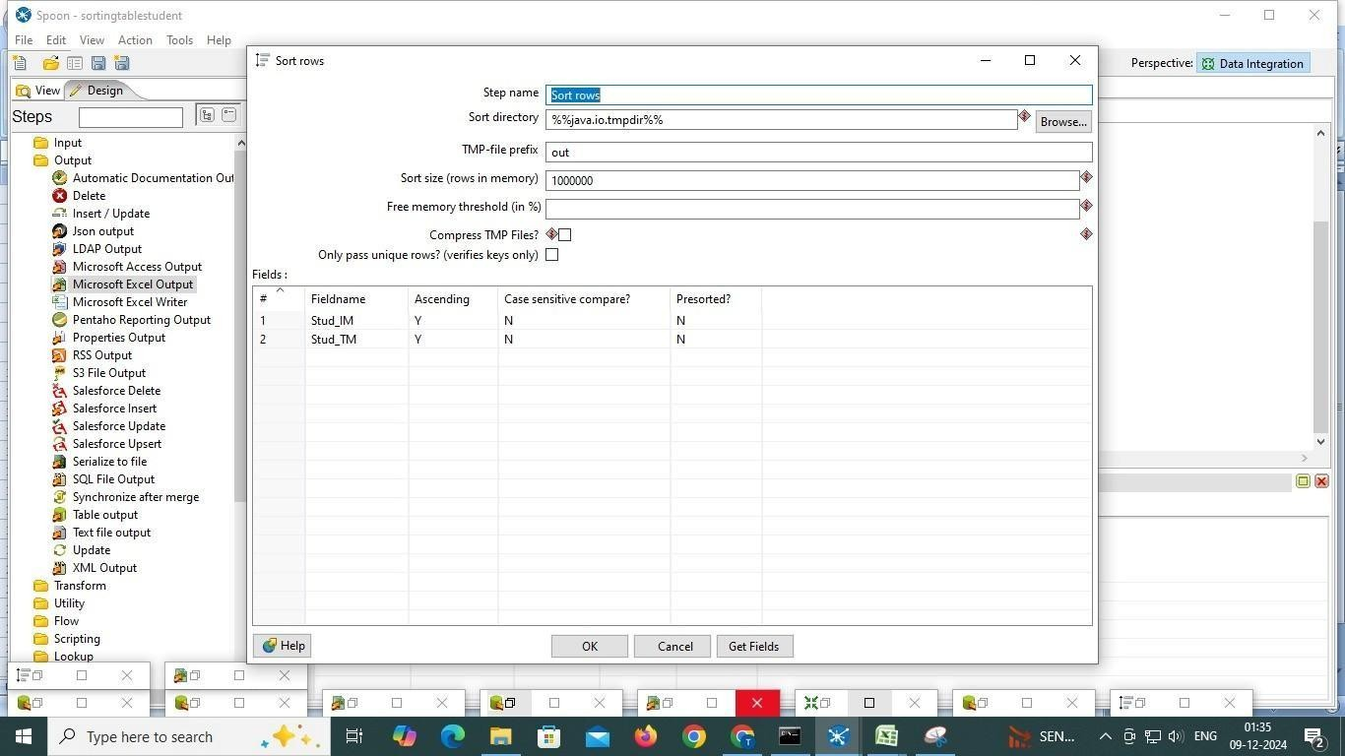

Step 8 : Click on run and see output

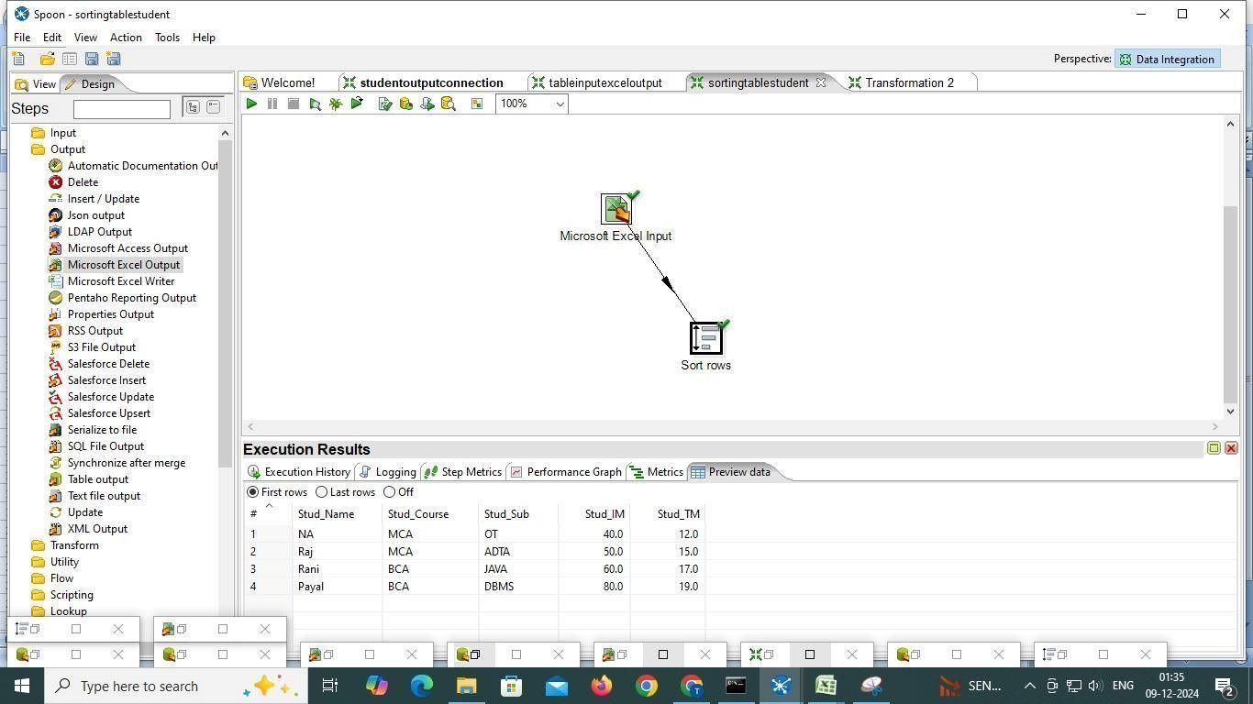

1. **Null-if**

**Step 1: Pull down the File menu and select the New menu item followed by Transformation.**



**Step 2: Add Table input**

**Step -3 Click on it add New coonection**

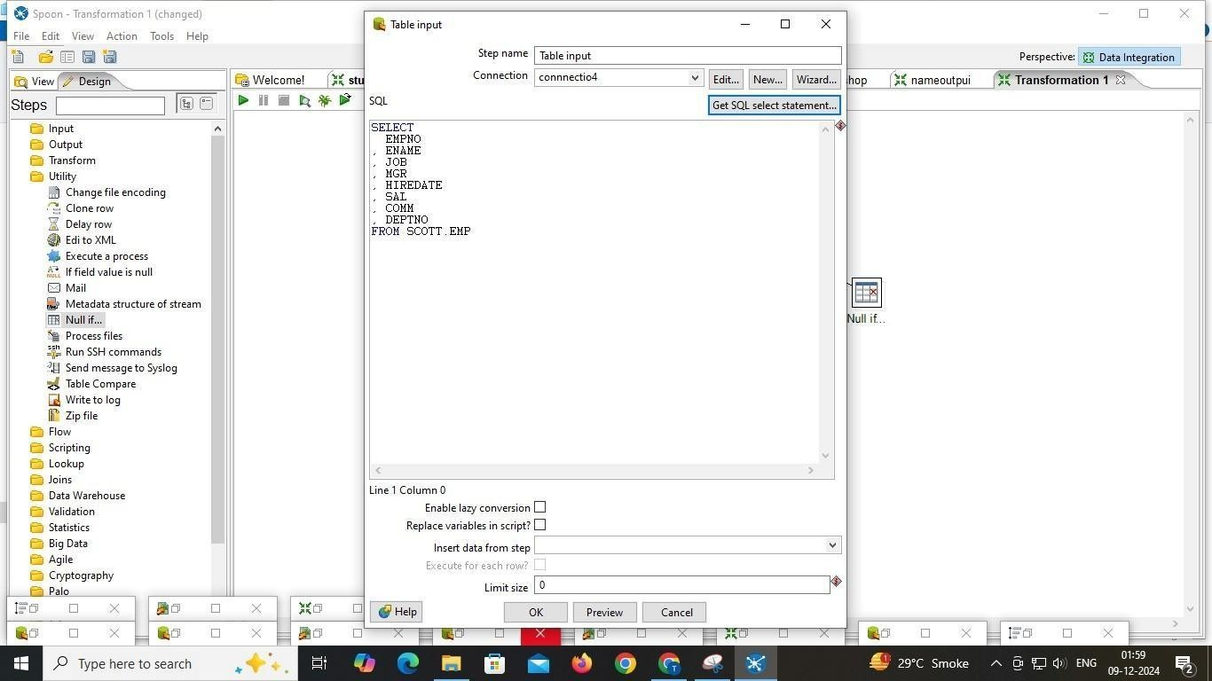

**Step -4 Add These Info**

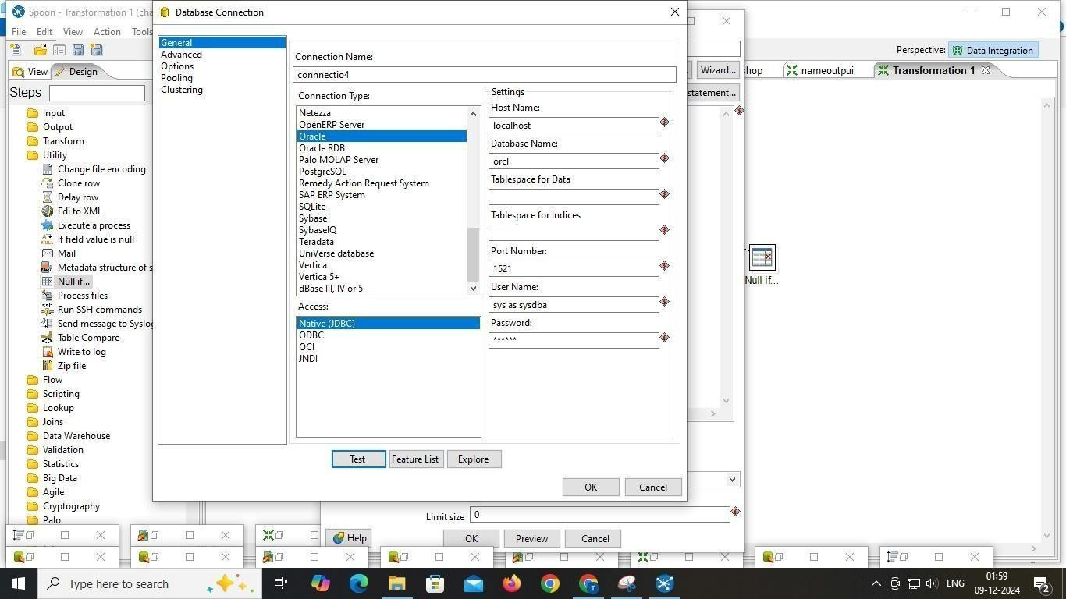

**Step :5 Click on ok And Preview And select these SCOOT**

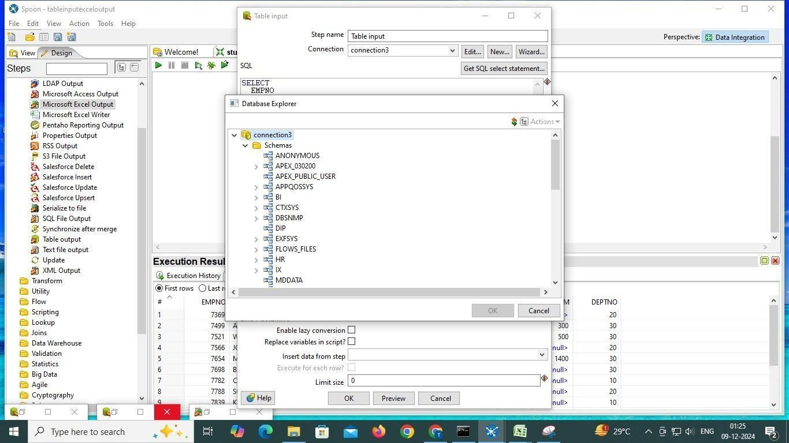

**Step 6: you have to get these scripts**

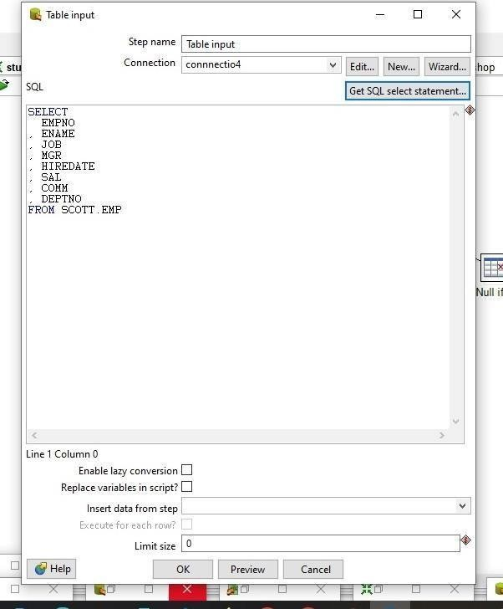

**Step 7: add NULL iff.. and coonect to table input**

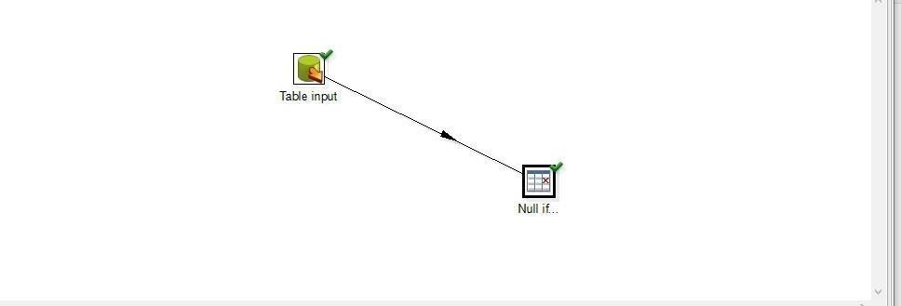

**Step 8: click on Null if file and Tell what value you have to null**

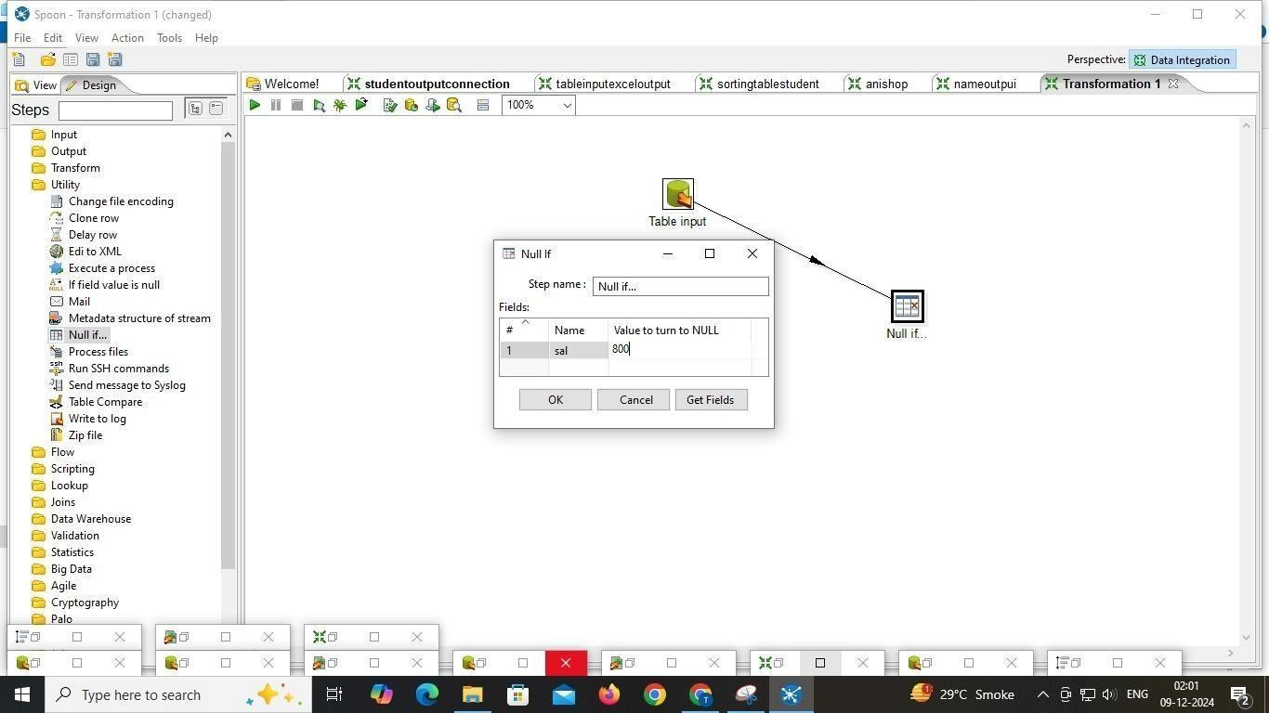

**Step 9: See output:**

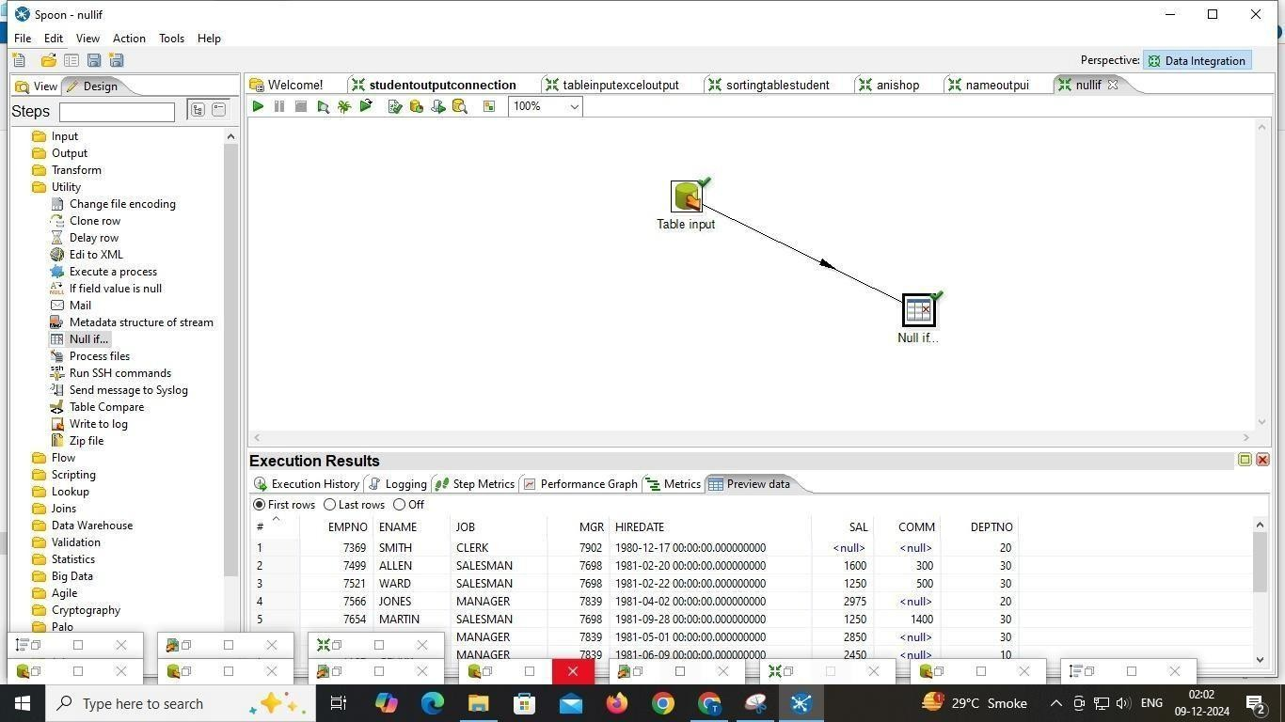

1. **String**

**Step 1: Pull down the File menu and select the New menu item followed by Transformation.**



**Step 2: Add Microsoft excel input Step3: add name.xls file**

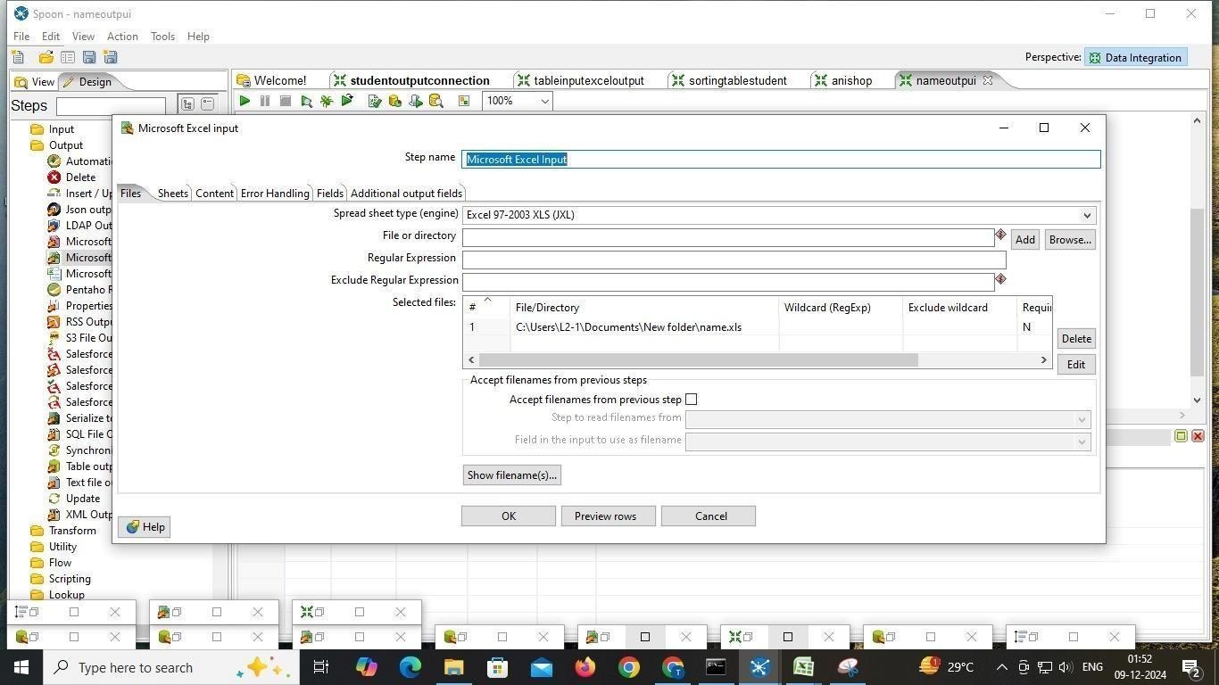

**Step 4: move sheet 1 file**

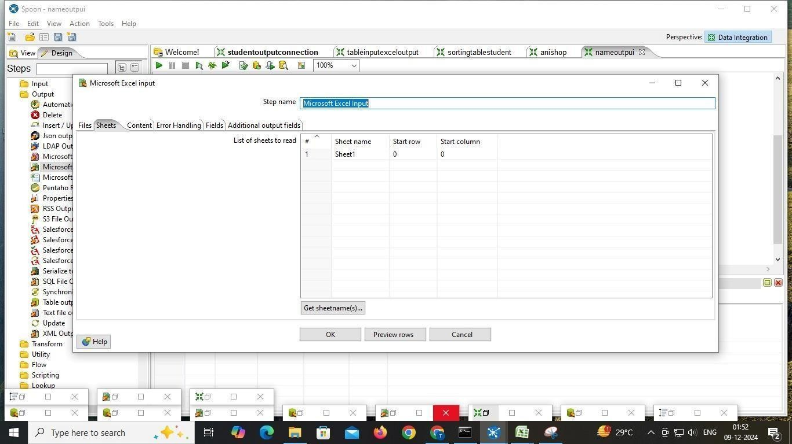

**Step 5: goto field section and click on get field**

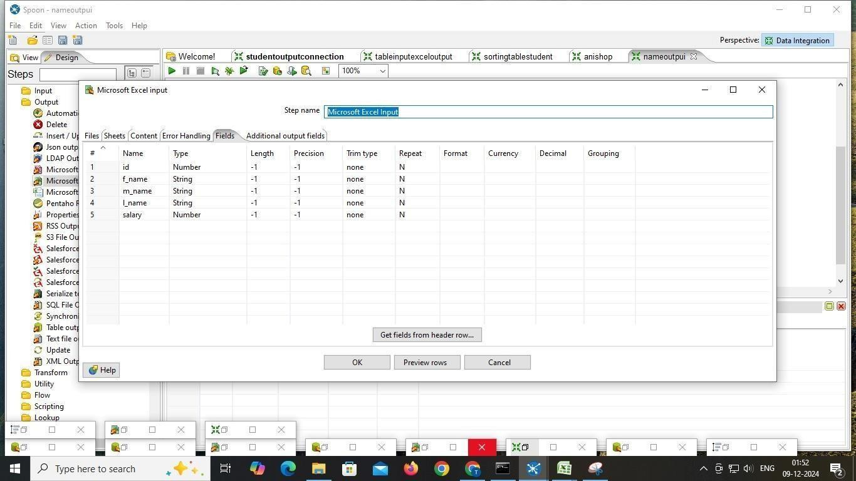

**See detail by click on preview**

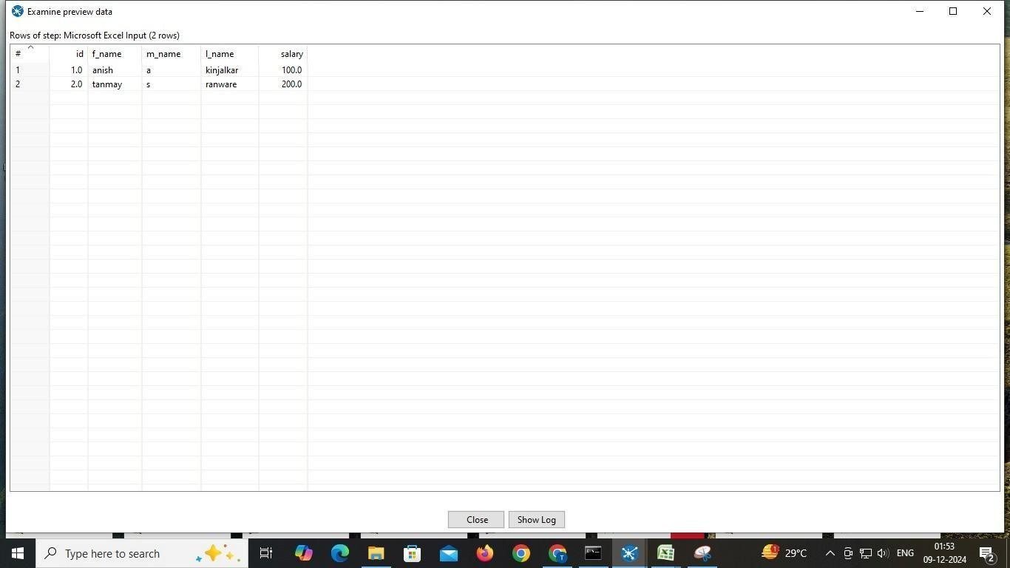

**Step 7: add Excel output and browse blank xls file**

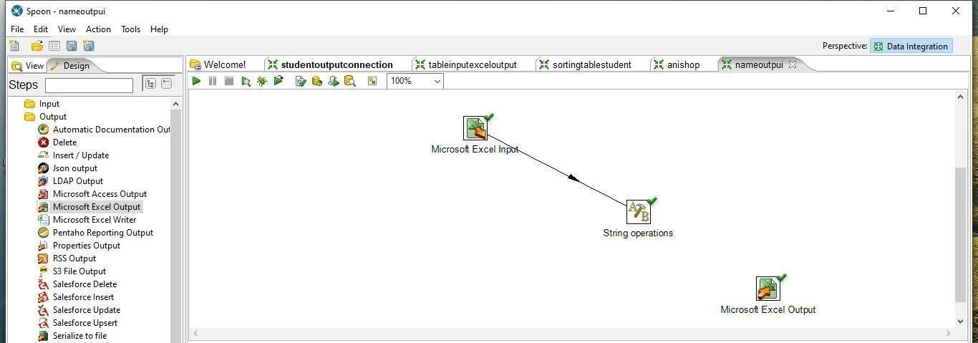

**Step 8: add String Operation and connect to input**

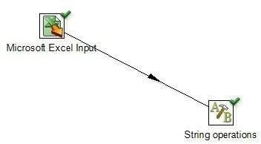

**Step 8: Click on string operation and fill field like below file**

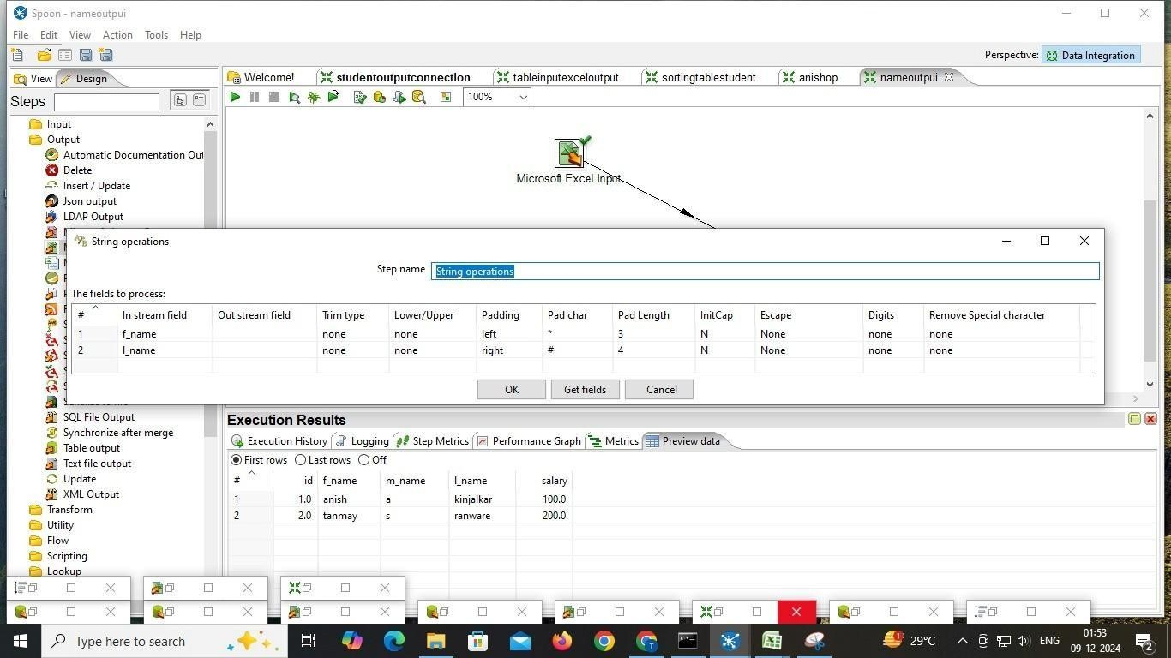

**Step 10: See output**

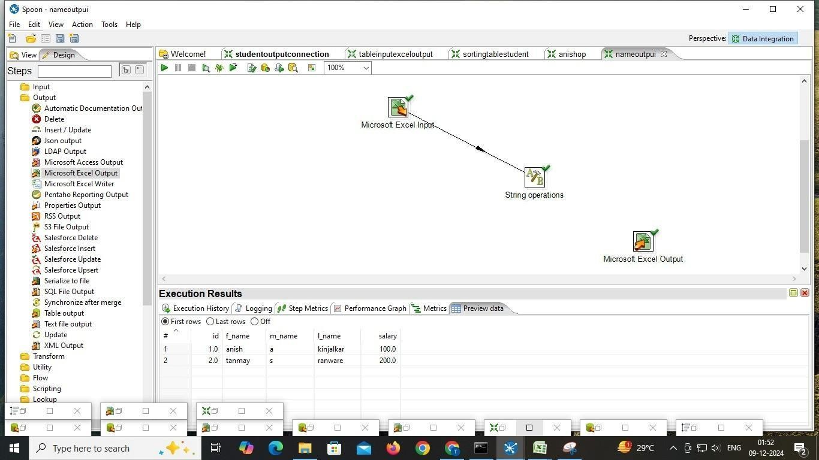

**PRACTICAL NO.05**

**AIM: Basics of R programming and Data Preprocessing: Introduction to R, Data Types and Objects, Reading and writing data, reading data from the console Packages, loading packages, Attach, and detaching data. Loading Data from different Data Source, Data preprocessing techniques in R**

1. Vector
   1. myString<-"Hello,World"

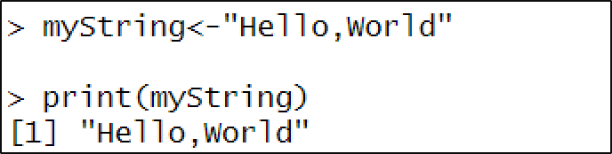

print(myStr

* 1. setwd("C:\Users\91970\OneDrive\Documents\Desktop") getwd()

dir()

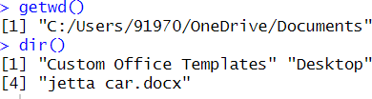

* 1. X <- 1 class(X) S<-'C'

is.integer(S) is.character(S) v<-'2.14'

as.integer(v)

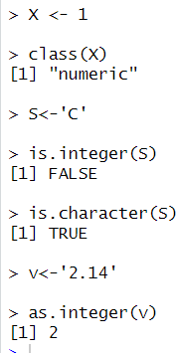

* 1. x<-c(11.4,13.4,15.4)

print(x)

y<-vector("logical",length=10) print(y)

length(x)

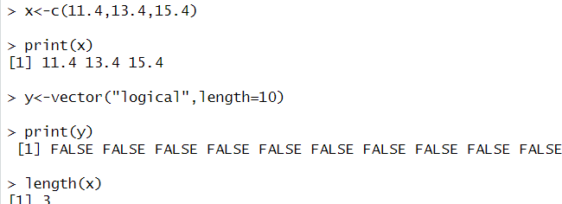

* 1. Addition of two vectors x1<-c(7,8)

y1<-c(5,8)

x1+y1

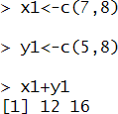

* 1. Using paste and paste() String1=c("mayura","Bhoir") fullname=paste("mayura","Bhoir") fullname
  2. Matrix

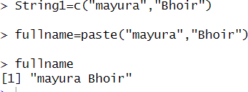

x<-matrix(c(11,12,13,14,15,16,17,18,19),nrow=3,ncol=3)

x dim(x)

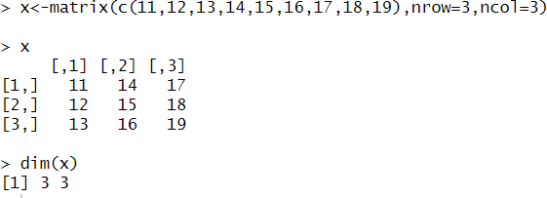

1. rbind() cbind()

a<-matrix(c(11,12,13,14,15,16,17,18,19),nrow=3,ncol=3) b<-c(21,22,23)

cbind(a,b)

p<-matrix(c(14,12,13,15,17,16,18,12,14),nrow=3,ncol=3) q<-c(10,11,12)

rbind(p,q)

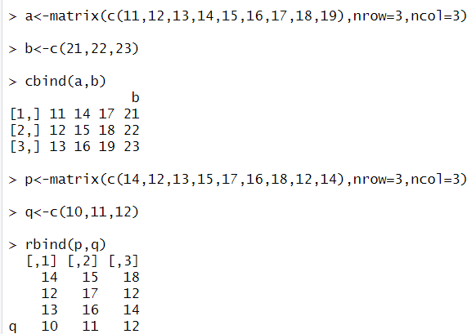

1. create four by four matrix and perform arithmetic operations on it

p<-matrix(c(11,12,13,14,15,16,17,18,21,22,23,31,32,33,34,35),nrow=4,ncol=4)

p

q<-matrix(c(21,32,43,54,34,32,34,21,31,41,51,44,33,55,66,54),nrow=4,ncol=4)

q

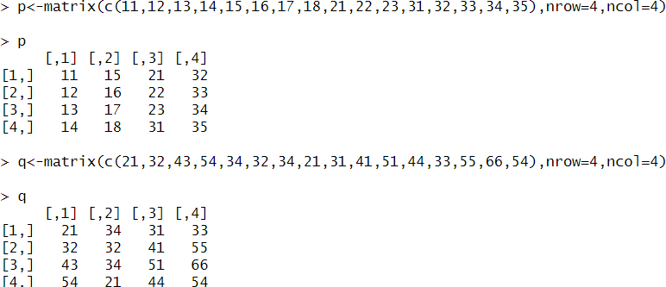

1. t=p+q

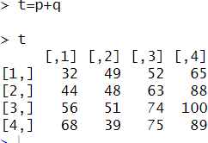

1. m=p-q m

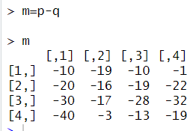

1. s<-p%*%q s

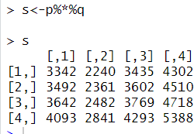

1. Transpose of matrix

>>tp<-t(p) tp

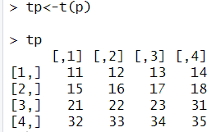

1. determinant of matrix

>>>a<-matrix(c(11,21,32,12,13,14,43,42,41),nrow=3,ncol=3)

a_det<-det(a) a_det

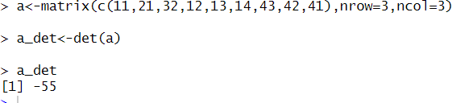

xii. list

>>>x<-list(1,'p',TRUE,2+4) X

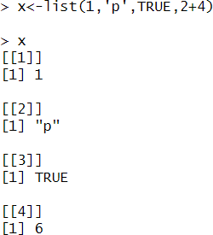

xiv. status<-c("low","high","medium","high","low")

x<-factor(status,ordered = TRUE,levels = c("low","medium","high")) x

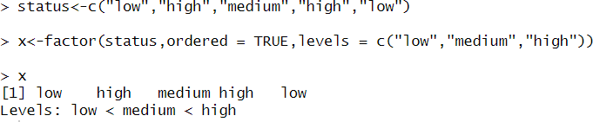

1. Data Frame
   1. >>> student_id<-c(1,2,3)

student_names<-c("Mahi","Nisha","Anjali") course<-c("BMS","MCA","MBA")

position<-c("First","Second","Third")

data<-data.frame(student_id,student_names,course,position) data

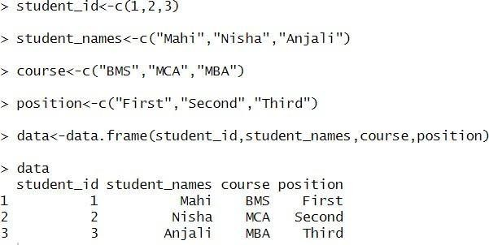

* 1. accessing particular column

>>>data$student_id

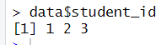

* 1. number of colums

>>>ncol(data)

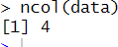

* 1. names of the column in data frame

>>>names(data)



* 1. creation of table

>>>smoke <- matrix(c(51, 43, 22, 92, 29, 21, 69, 22, 9), nrow = 3, byrow = TRUE) colnames(smoke) <- c("High", "Low", "Medium")

rownames(smoke) <- c("current", "former", "never") smoke <- as.table(smoke)

smoke

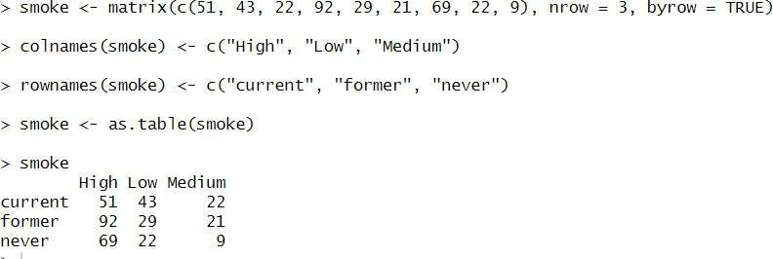

Vi . Reading and Writing data using XL connect

>install.packages(“XLConnect”)

>install.packages(“readxl”)

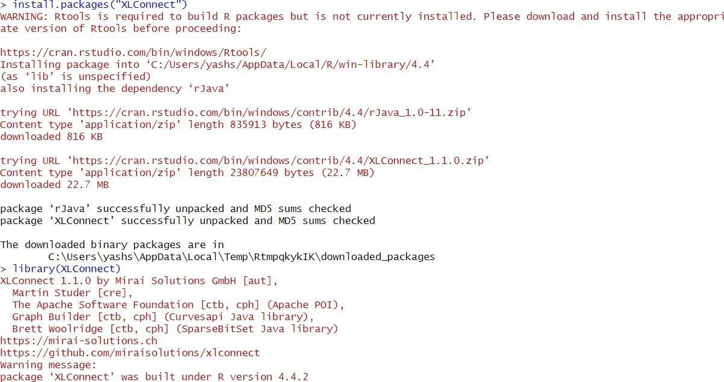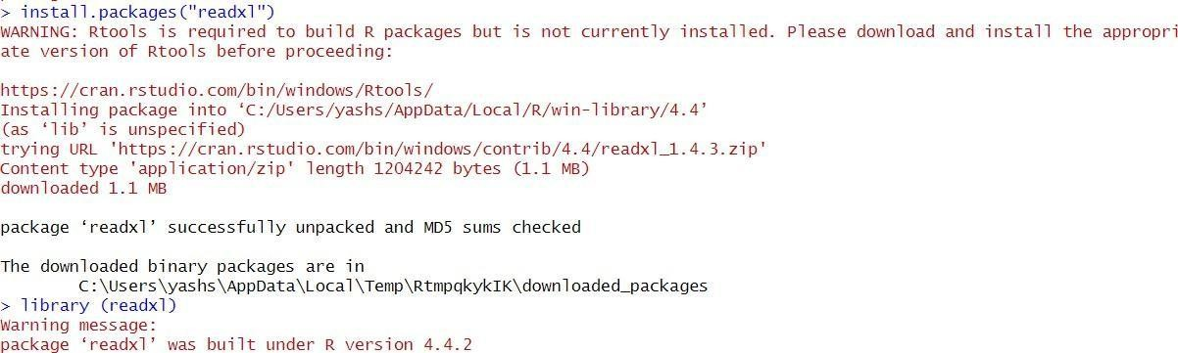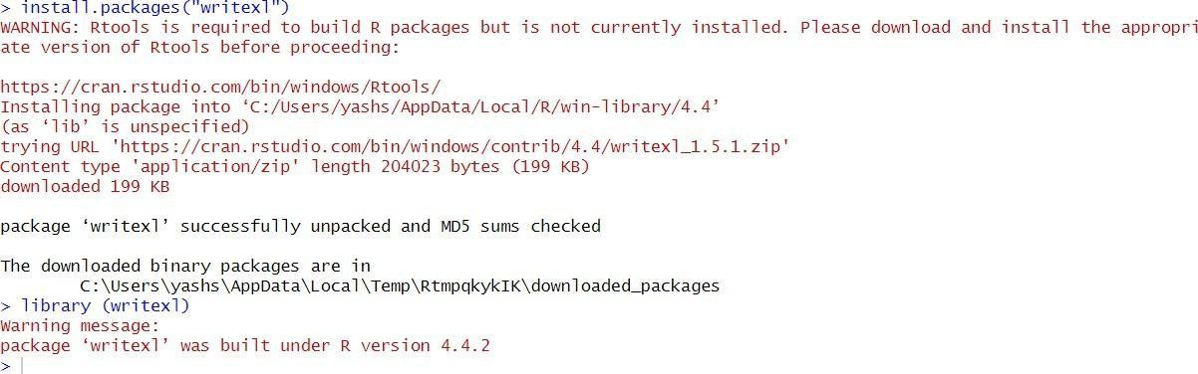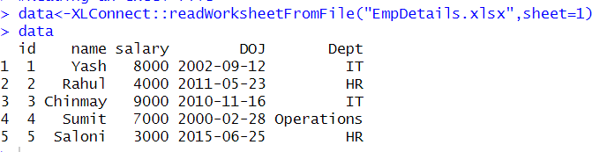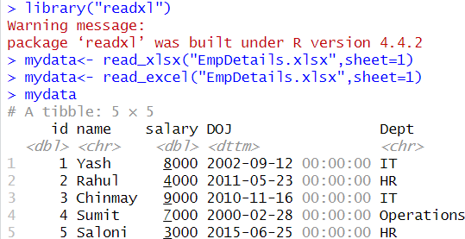

>library(writexl)

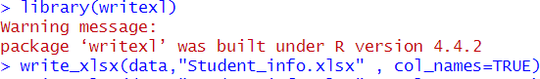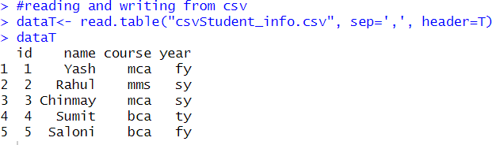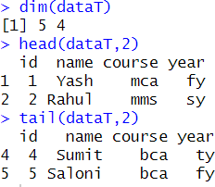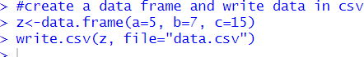

1. Data Preprocessing using R
   1. Displaying first six rows from the data uding head()

>>>my_data<-mtcars head(my_data,6)

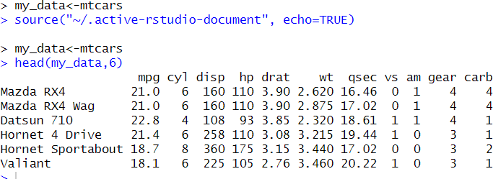

* 1. #[1:6 displays rows and 1:5 displays columns]

>>>my_data1<-my_data[1:6,1:5] my_data1

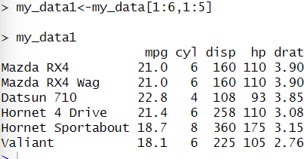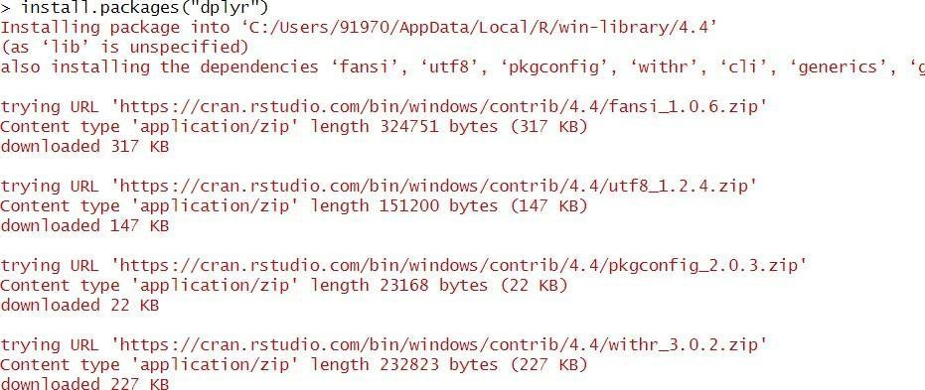

* 1. install.packages("dplyr") require(dplyr)

my_data1<-rename(my_data1,horse_power=hp) my_data1

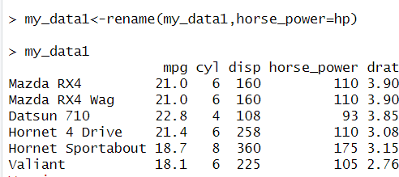

* 1. my_data1$new_hp1=my_data1$horse_power*0.5 colnames(my_data1)

my_data1

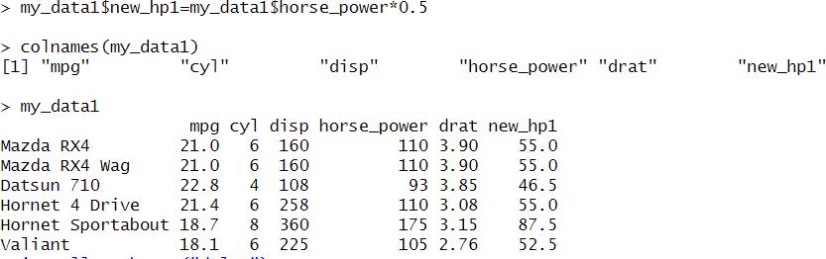

* + 1. install.packages("Hmisc") library(Hmisc)

x<-c(1,2,3,NA,4,4,NA)

x<-impute(x,fun=mean) x

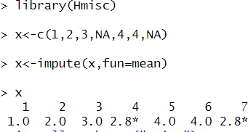

* + 1. x<-impute(x,fun=median) x

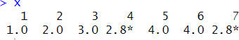

* + 1. gender_vector<-c("Male","Female","Male","Male") class(gender_vector)

factor_gender_vector<-factor(gender_vector) class(factor_gender_vector)

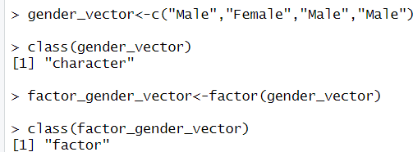

* + 1. day_vector<-c('Evening','Morning','Afternoon','Midday','Midnight','Evening') factor_day<- factor(day_vector,order=TRUE,levels=c('Morning','Midday','Afternoon','Evening', 'Midnight'))

factor_day

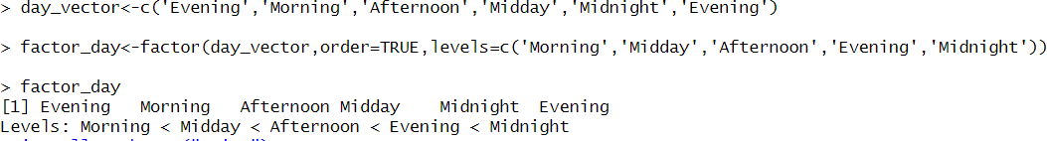

* + 1. age<-c(40,49,48,40,67,52,53)

salary<-c(10300,11500,32000,12400,10390,14500,15000)

gender<- c("Male","Female","Transgender","Female","Male","Female","Transgender")

employee<-data.frame(age,salary,gender) employee

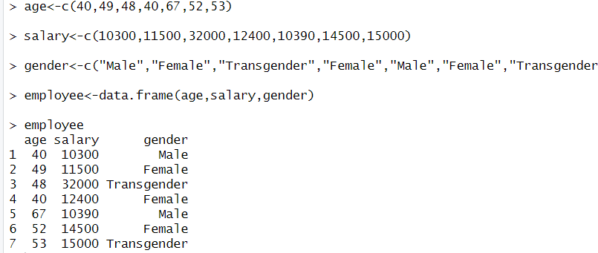

* + 1. wfact<-cut(employee$age,3,labels=c('Young','Medium','Aged')) table(wfact)

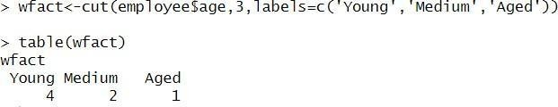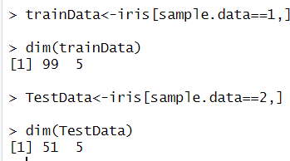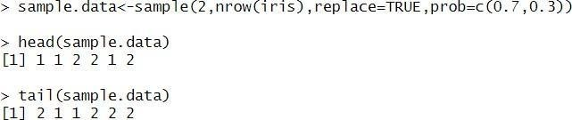

**PRACTICAL NO:06**

**AIM: Data Mining Classification using R Programming: Implementation and Analysis of – Regression - Linear Regression, Classification Models (Naïve bayes, KNN, Decision Trees-ID3, C4.5)**

Implementation andanalysis of Classification algorithm like:

1. Decision Tree Algorithm

>>> data(iris) dim(iris) str(iris)

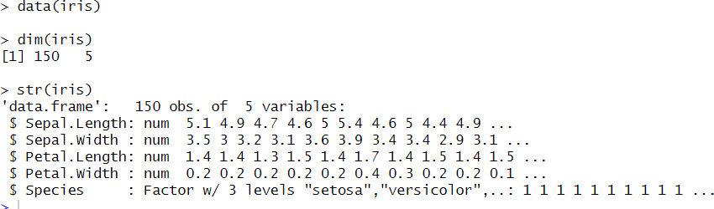

>>> sample.data<-sample(2,nrow(iris),replace=TRUE,prob=c(0.7,0.3)) head(sample.data)

tail(sample.data)

>>> trainData<-iris[sample.data==1,] dim(trainData)

TestData<-iris[sample.data==2,] dim(TestData)

>>>install.packages("party") library(party)

myformula<-Species~Sepal.Length+Sepal.Width+Petal.Length+Petal.Width iris_ctree<-ctree(myformula,data=trainData) table(predict(iris_ctree),trainData$Species)

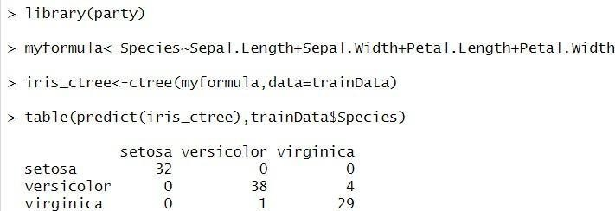

>>>plot(iris_ctree)

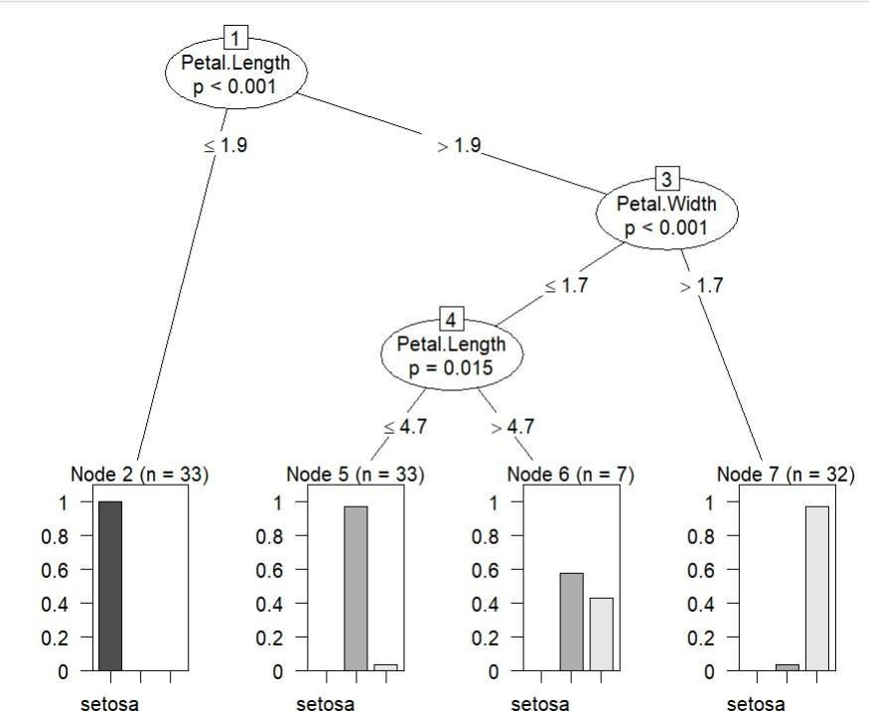

>>>plot(ctree_model, type = "simple")

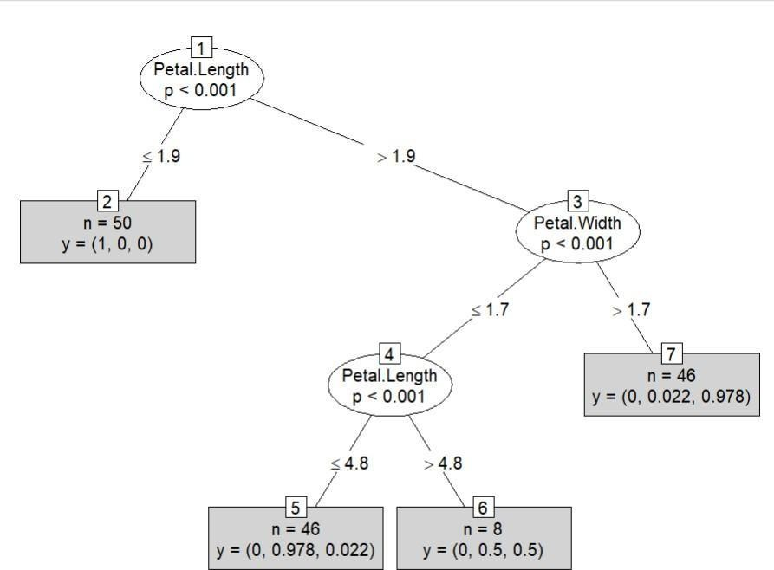

**ii). Naïve Bayesian**

* #loading required all libraray install.packages(e1017) library(klaR)

library("caret") library(ggplot2) data(iris) head(iris)

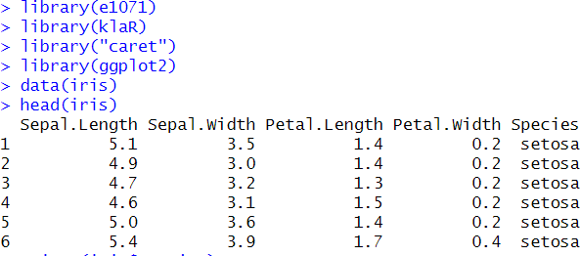

>unique(iris$Species)

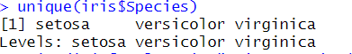

* pairs(iris[1:4],main="Iris" Data(red=setosa,green=versicolor,blue=virginica)",+ pch=21,bg("red","green3","blue"[unclass(iris$Species)])

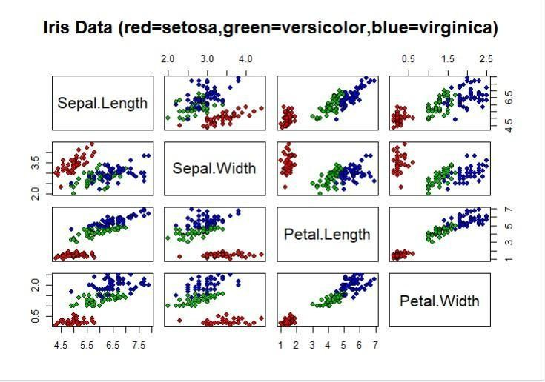

* index=sample(neow(iris),floor(nrow(iris)*0.7)) train=iris[index,]

test=iris[-index,] xtrain1=[,-5] ytrain1=train$Species xtest=test[,-5] ytest=test$Species

model=reain(xtrain1,ytrain1,'nb',trControl=trainControl(method='cv',number=10)) model

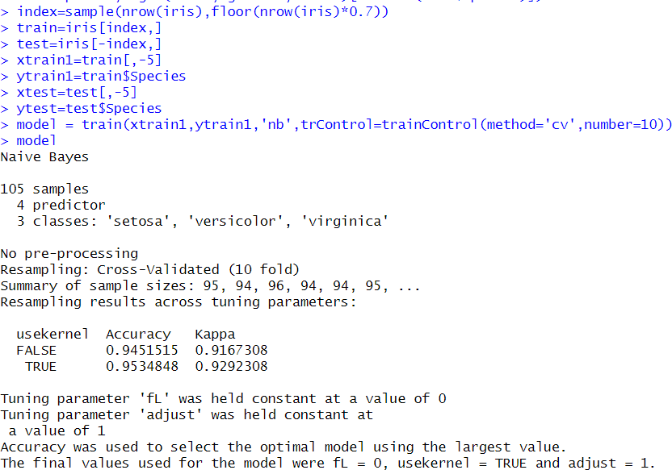

.>prop.table(table(predict(model$finalModel,xtest)$class,ytest))

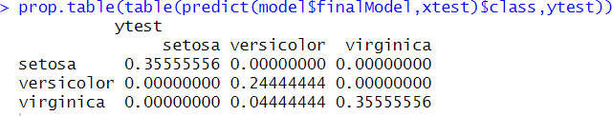

**iii. K Neirest Neighbour (KNN)**

>#loading data def<-data(iris) head(iris)

def<-data(iris) head(iris)

ran=Sample(1:nrow(iris),0.9*nrow(iris)) nor=function(x){(x-min(x))/(max(x)-min(x))} iris_norms=as.data.frame(lapply(iris[,c(1,2,3,4)],nor)) summary(iris_norms)

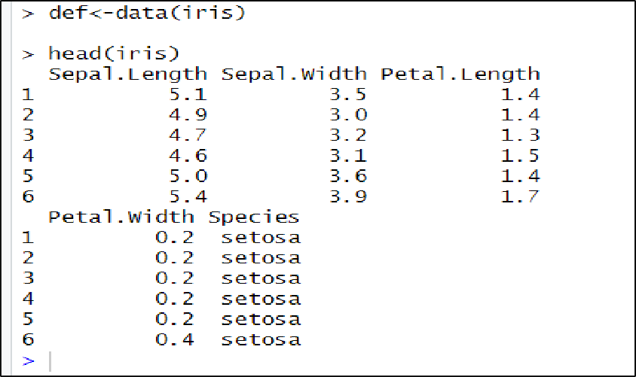

>

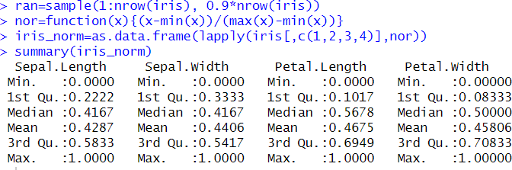

* iris_train<-iris_norm[ran,] dim(iris_train)

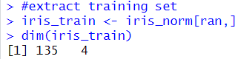

* iris_test<-iris_norm[-ran,] dim(iris_test)

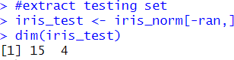

* iris_target_category<-iris[ran,5] iris_test_category<-iris[-ran,5] library((class)

pr<-knn(iris_train,iris_test,cl=iris_target_category,k=13) tab<-table(pr,iris_test_category)

accuracy<-function(x){sum (diag(x)/sum(rowSums(x))))*100}

accuracy(tab)

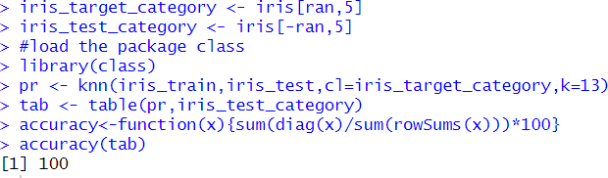

**Linear Regression**

* **Simple Linear Regression to predict weight of a person based on height.**
* x<-c(151,174,138,186,128,136,179,162,152,131) y<-c(63,81,56,91,47,57,76,72,62,48)

relation<-lm(y~x) print(relation)

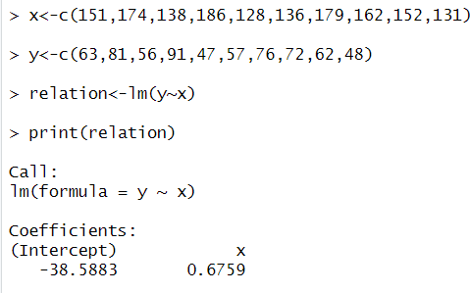

* a<-data.frame(x=170) result<-predict(relation,a) print(result)

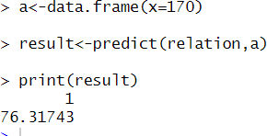

>plot(y,x,col="blue",main="height & weight",abline(lm(x~y)),cex=1.3,pch=18,xlab="weight in KG",ylab="Height in cm")

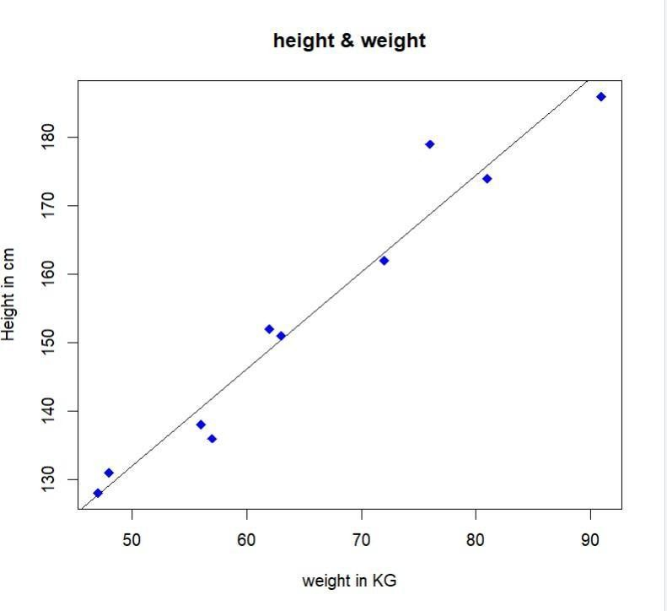

**Analysis of Linear Regression using dataset.**

* library(ggplot2) my_data<-mtcars head(my_data,5)

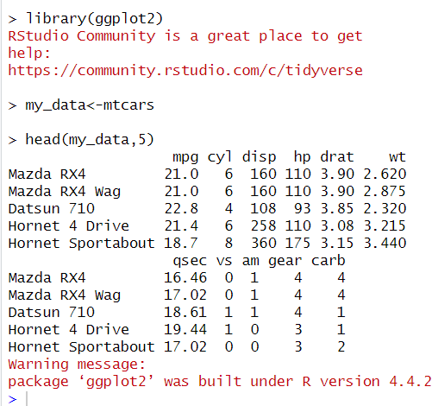

* dim(my_data)

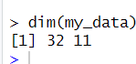

* head(my_data)

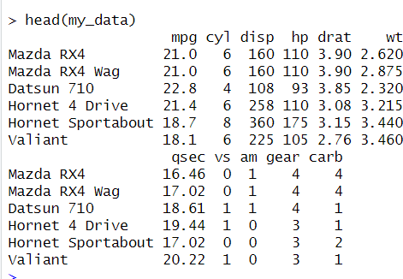

* TrainData<-my_data[1:20,] print(TrainData)

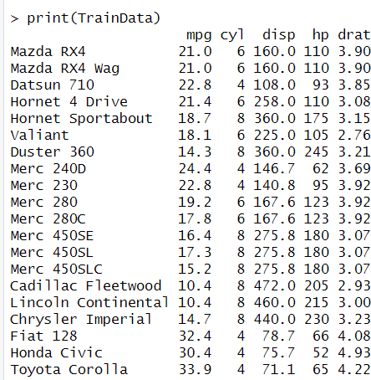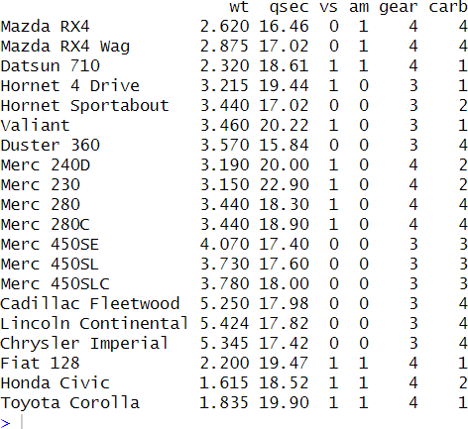

* fit=lm(mpg~hp,data=mtcars) summary(fit)

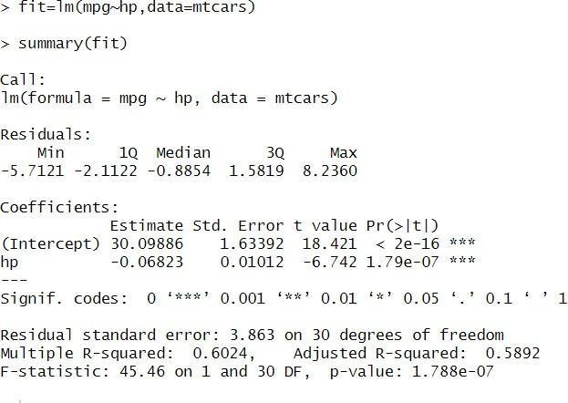

* pred<-predict(fit,newdata=TestData) df1=data.frame(pred,TestData$mpg) print(df1)

head(df1)

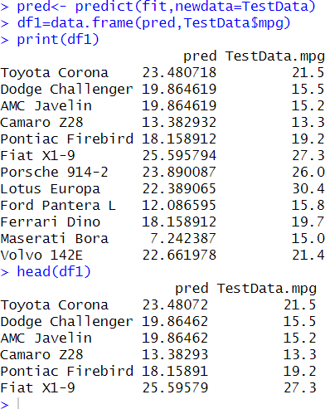

* cor(pred,TestData$mpg**)**

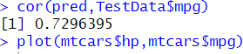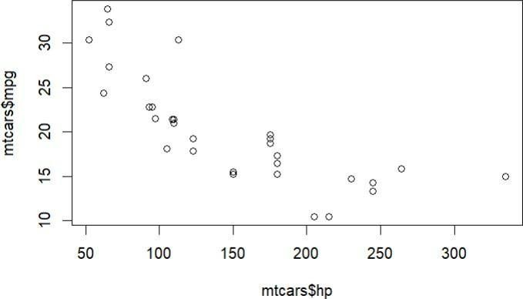

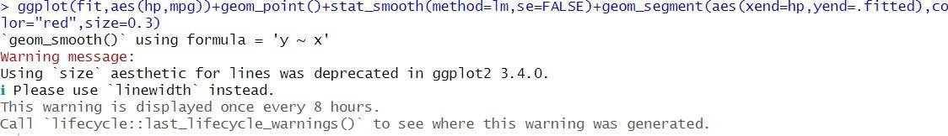

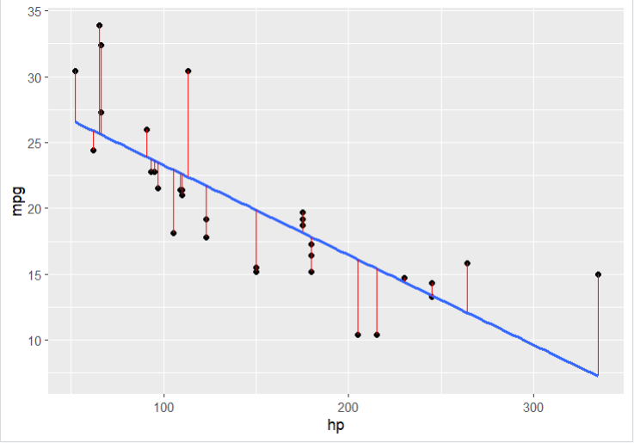

**PRACTICAL NO:07**

**AIM: Data Mining Clustering and Association using R Programming: Implementation of Market Basket Analysis and Clustering. APRIORI, KMEAN, AGGLOMERATIVE**

**i). APRIORI**

>>dataC<-read.csv(file="C://Users//91970//OneDrive//Documents//Desktop") trans<-split(dataC$Products,dataC$Customer_Id)

head(trans)

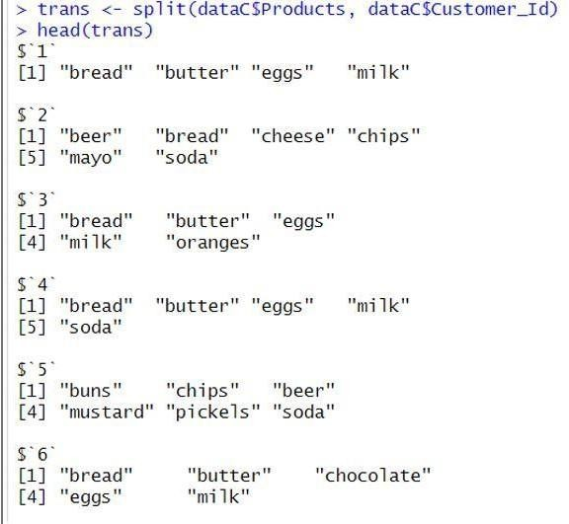

>>trans<-as(transactions(trans),"transactions") library(arules)

rules<-apriori(trans,parameter=list(support=0.5,confidece=0.9,maxlen=3,minlen=2))

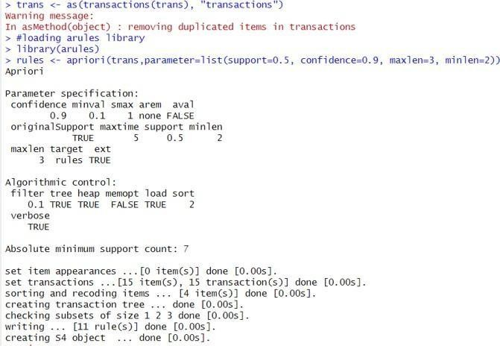

>inspect(rules)

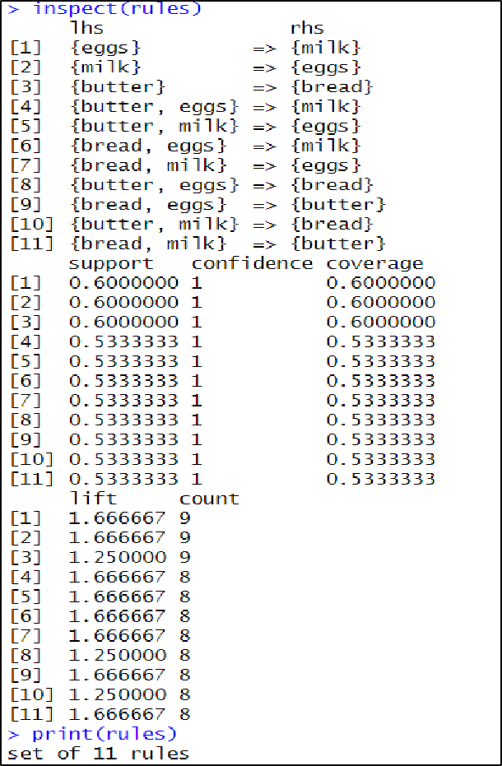

>

1. **K-MEAN**

>head(iris)

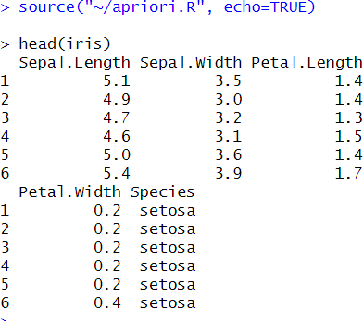

>library(ggplot2) ggplot(iris,aes(Petal.Length,Petal.Width,color=Species))+geom_point()

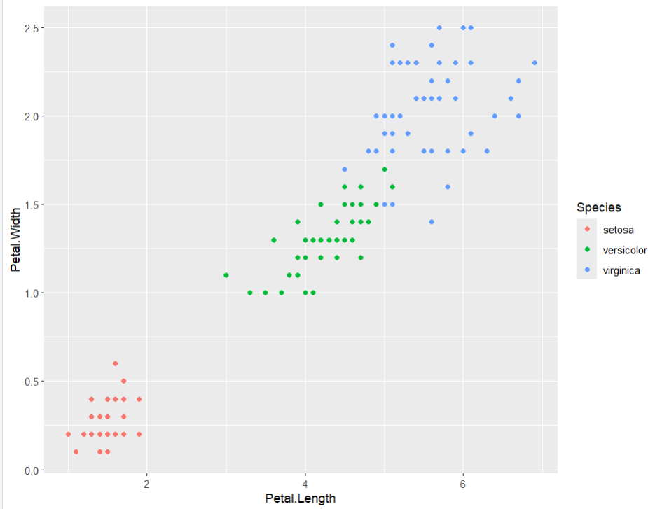

>set.seed(20)

irisCluster<-kmeans(iris[,3:4],3,nstart=20) irisCluster

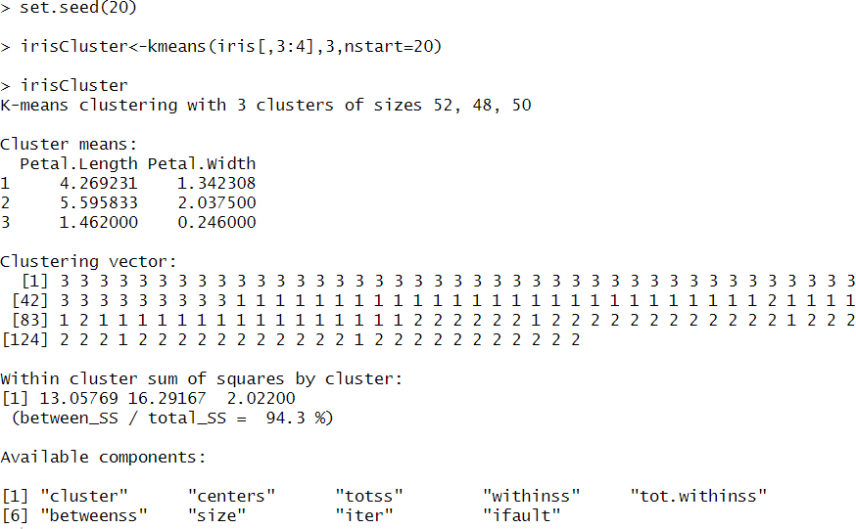

>table(irisCluster$cluster,iris$Species)

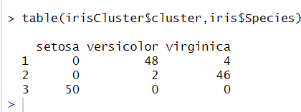

>irisCluster$cluster<-as.factor(irisCluster$cluster) ggplot(iris,aes(Petal.Length,Petal.Width,color=irisCluster))+geom_point()

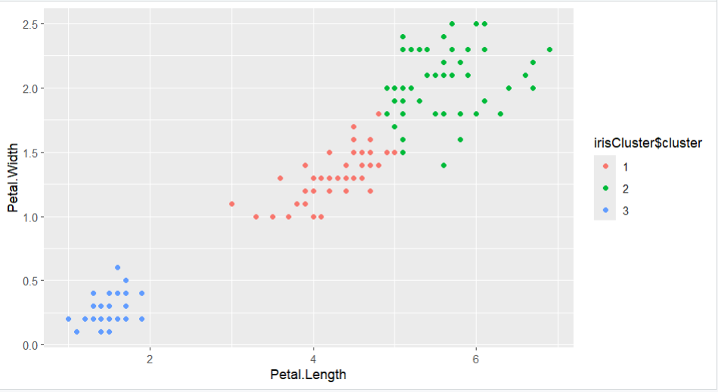

ii. Agglomerative Clusturing

>clusters<-hclust(dist(iris[,3:4])) plot(clusters)

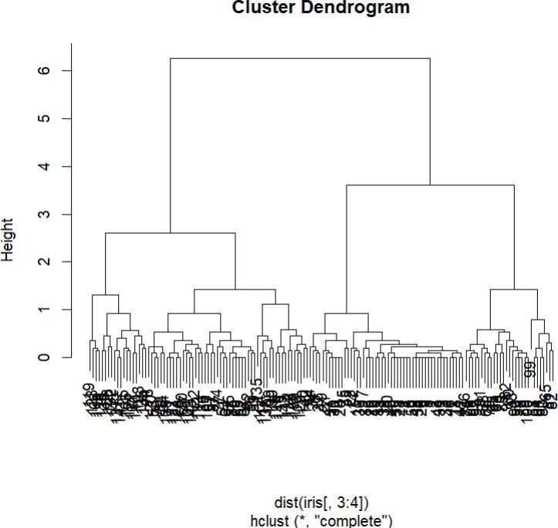

>clusterCut<-cutree(clusters,3) table(clusterCut,iris$Species)

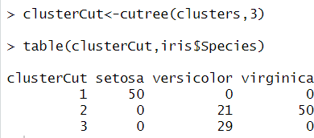

>clusters<-hlust(dist(iris[,3:4]),method='average') plot(clusters)

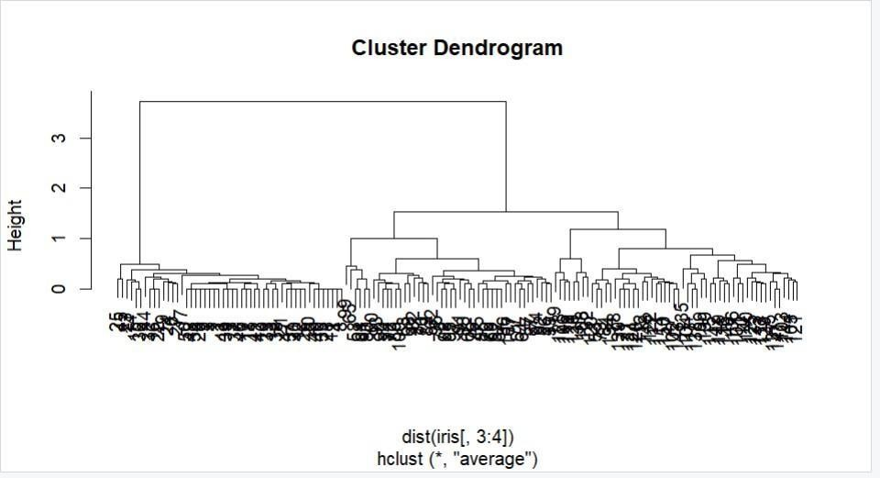

>clusterCut<-ctree(clusters,3) table(clusterCut,iris$Species)

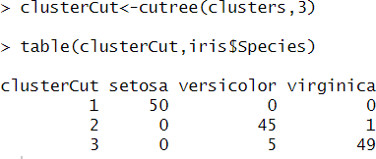

>library(ggplot2) ggplot(iris,aes(Petal.Length,Petal.Width))+ geom_point(aes(color=Species),alpha=0.4,size=3.5)+

geom_point(aes(color=factor(clusterCut)),shape=1,size=3.5)+ scale_color_manual(values=c('black','red','green','blue','orange','purple'))

